[Jenkins Tutorials for Beginners | Continuous Integration Tutorials - YouTube](https://www.youtube.com/watch?v=e8tEF_1jx84&list=PL5nViEmyYI0bmfcM_s4P-dfzKrOpcFWWK&index=21):

LIGHTSHOT  
<https://www.youtube.com/watch?v=e8tEF_1jx84&list=PL5nViEmyYI0bmfcM_s4P-dfzKrOpcFWWK&index=21>

<https://www.youtube.com/watch?v=WbZGmKhsiug&list=PL5nViEmyYI0bmfcM_s4P-dfzKrOpcFWWK&index=22>

https://www.youtube.com/watch?v=xbfGrn92MMc&list=PL5nViEmyYI0bmfcM\_s4P-dfzKrOpcFWWK&index=23

NEXUS:

Username:admin

Password:admin123

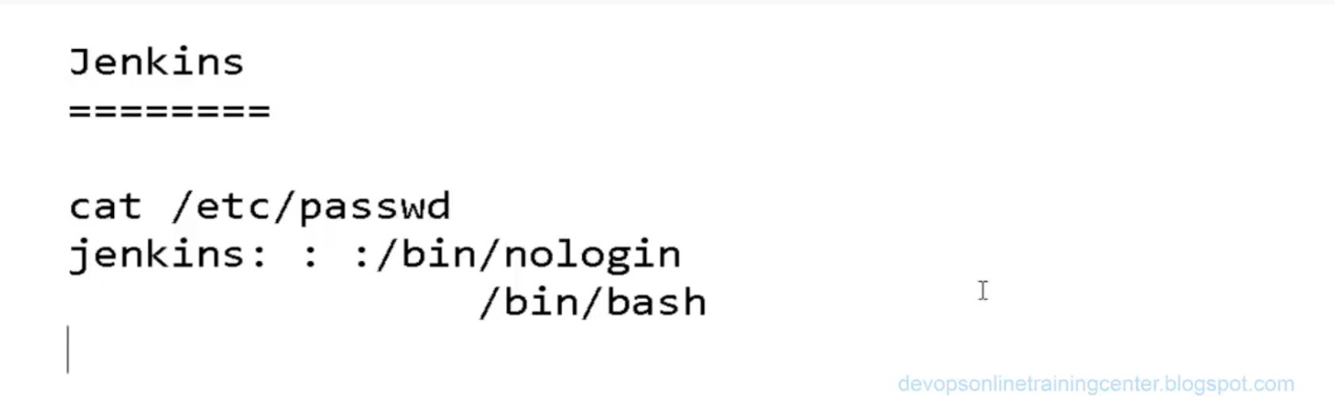

If system not allow us to login as Jenkins, then check into cat /etc/passwd

If it is showing Jenkins: : :/bin/nologin

Then edit the file and make changes as :

Cat /etc/passwd

Jenkins: : :/bin/bash

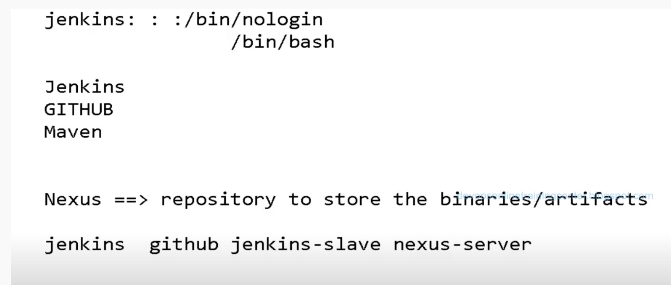

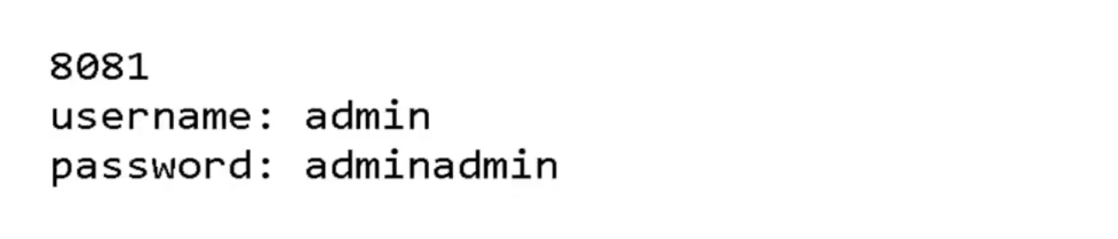

2 ways we can download and install NEXUS on agent

* + 1. Download and copy from local machine
  + Download Nexus on local machine and from local machine copy it to agent/slave machine:

$scp /downloads/nexus.tar root@agent:/

* + Allow permit login onto the agent at /etc/ssh/sshd\_config file
  + Then copy from local and unzip it by below screen-shot.

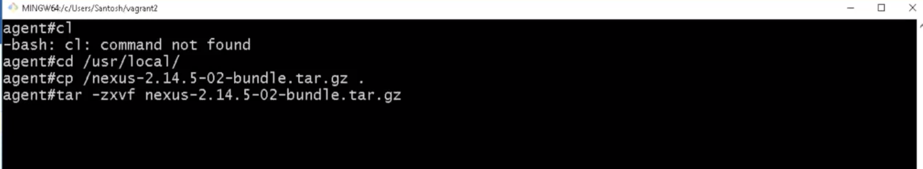

2) 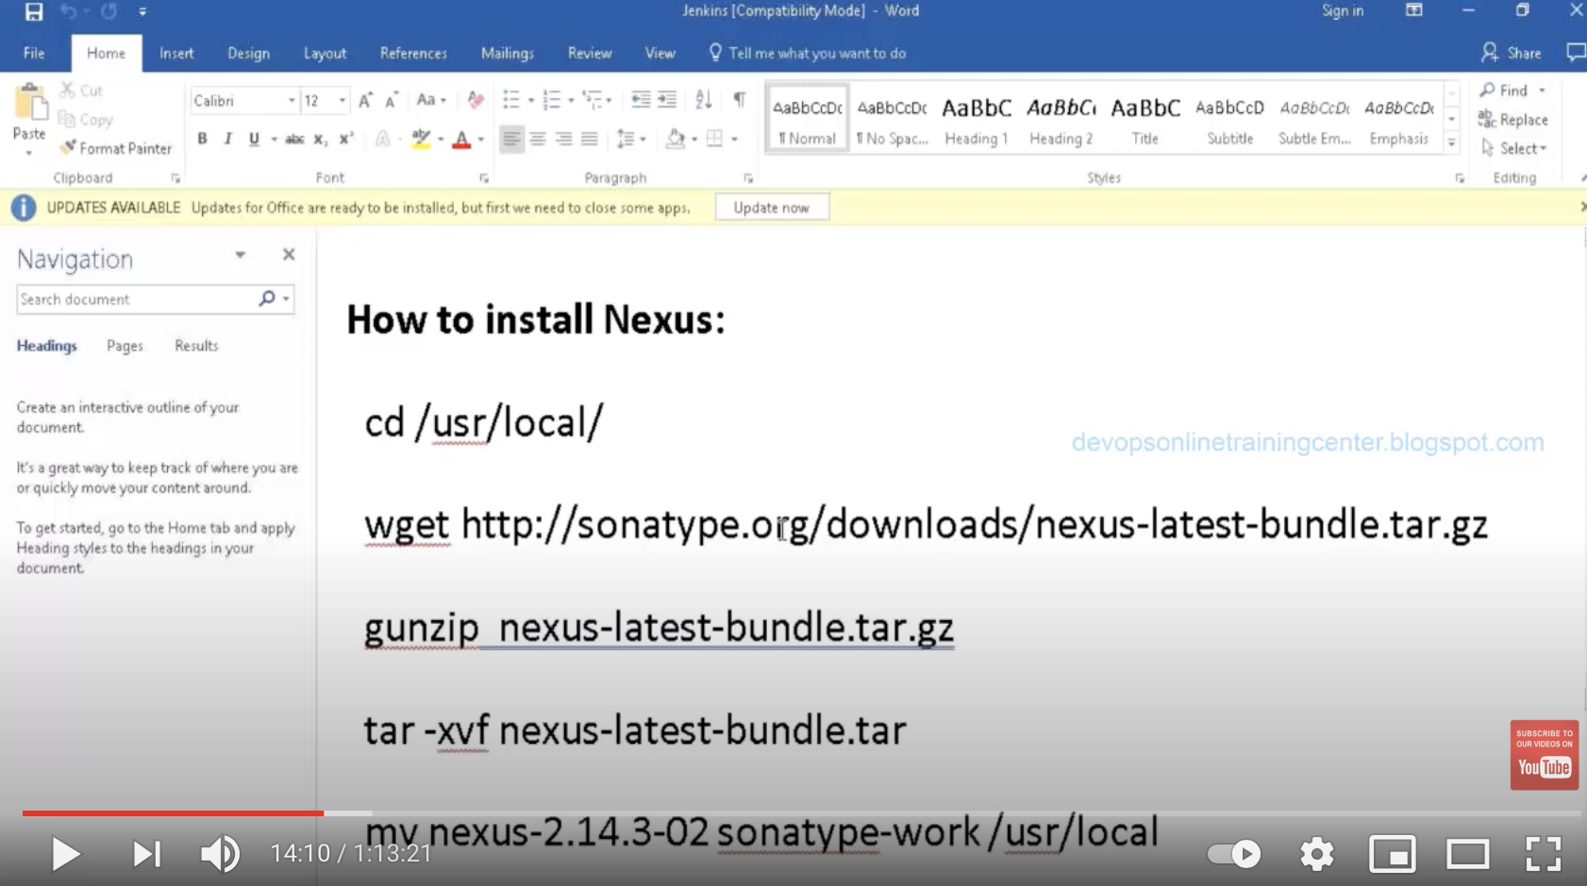

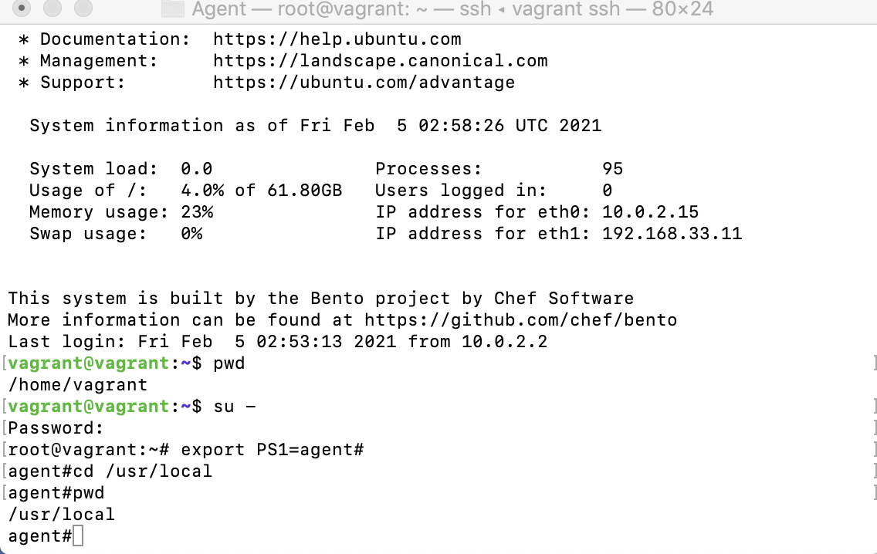

**How to download and install nexus URL below:**

<https://devopscube.com/how-to-install-latest-sonatype-nexus-3-on-linux/>

To check the nexus process if running or not.

Agent#ps -ef | grep -i nexus

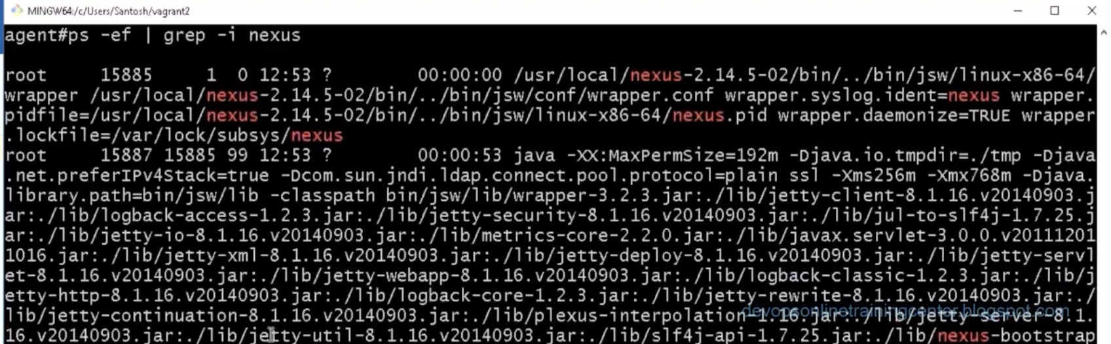

What I have now (after update-java-alternatives) is

$ sudo update-alternatives --config java

There are 2 choices for the alternative java (providing /usr/bin/java).

Selection Path Priority Status

------------------------------------------------------------

0 /usr/lib/jvm/java-11-openjdk-amd64/bin/java 1101 auto mode

1 /usr/lib/jvm/java-11-openjdk-amd64/bin/java 1101 manual mode

\* 2 /usr/lib/jvm/java-8-openjdk-amd64/jre/bin/java 1081 manual mo

<https://docs.datastax.com/en/jdk-install/doc/jdk-install/installOpenJdkDeb.html>

/usr/lib/jvm/java-8-openjdk-amd64#

**nexus@vagrant**:**/app/nexus-3.29.2-02/bin**$ vi nexus

https://help.sonatype.com/repomanager2/installing-and-running/running

Step1:Create floder app and cd app.

Step2: create user nexus in that floder.

root@vagrant$Sudo adduser nexus

Change/set the password of user nexus on root path:

root@vagrant$sudo passwd nexus

Give the root access privileges to nexus user , add nexus user as mentioned in below:

root@vagrant:visudo

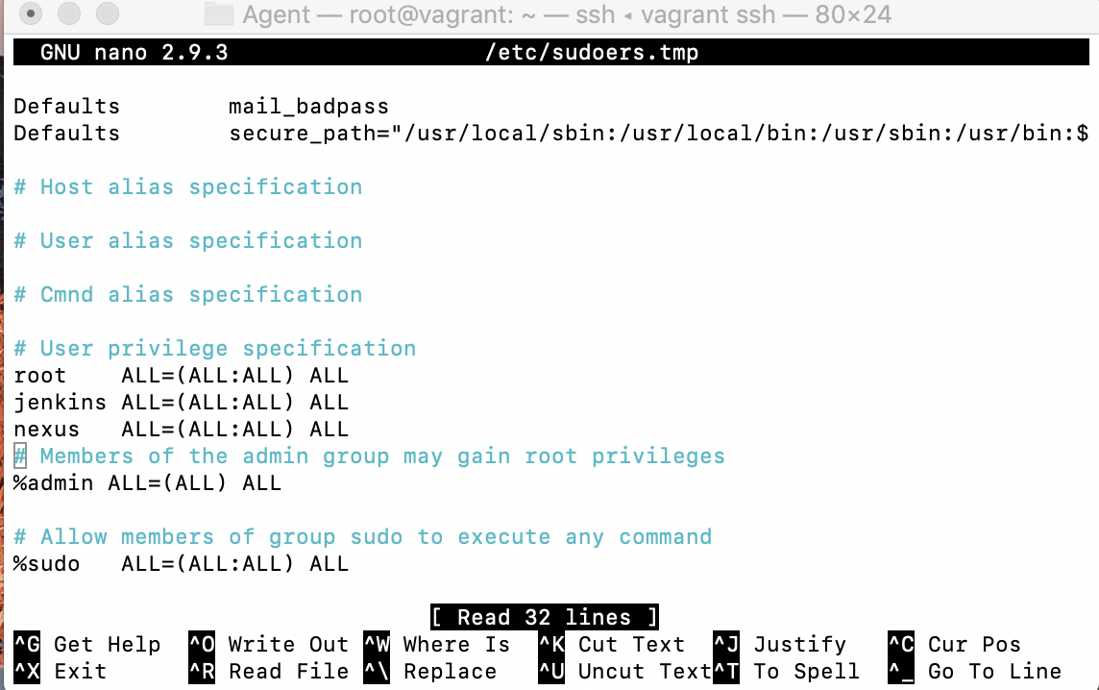

Step3: Install JDK 1.8 and if OpenJDK 11 is installed already then select the JDK8 only

$ sudo update-alternatives --config java

There are 2 choices for the alternative java (providing /usr/bin/java).

Selection Path Priority Status

------------------------------------------------------------

0 /usr/lib/jvm/java-11-openjdk-amd64/bin/java 1101 auto mode

1 /usr/lib/jvm/java-11-openjdk-amd64/bin/java 1101 manual mode

\* 2 /usr/lib/jvm/java-8-openjdk-amd64/jre/bin/java 1081 manual mo

<https://docs.datastax.com/en/jdk-install/doc/jdk-install/installOpenJdkDeb.html>

/usr/lib/jvm/java-8-openjdk-amd64#

Step 4:

Switch to user nexus

$su – nexus

Step5: Install the nexus.

How To Install Latest Sonatype Nexus 3 on Linux

* Last Updated On: September 28, 2019
* [By: devopscube](https://devopscube.com/author/devopscube/)

Sonatype Nexus is one of the best repository managers out there. It is some tool that you cannot avoid in your CI/CD pipeline. It effectively manages deployable artifacts.

Sonarqube requirements

1. Minimum 1 VCPU & 2 GB Memory
2. Server firewall opened for port 22 & 8081
3. OpenJDK 8
4. All Nexus process should run as a non-root nexus user.

**Note**: For production setup, please consider minimum production hardware requirements based on the nexus usage and data storage. Checkout the [official system requirements document](https://help.sonatype.com/repomanager3/system-requirements)for detailed information

Sonatype Nexus 3 on Linux ec2

This article guides you to install and configure Sonatype Nexus 3 in a secure way on an ec2 Linux System.

**Note**: This was tested on a Redhat machine and it will work on Centos or related Linux flavours as well.

**Step 1:** Login to your Linux server and update it. Also install required utilities.

sudo yum update -y

sudo yum install wget -y

**Step 2:** Install OpenJDK 1.8

sudo yum install java-1.8.0-openjdk.x86\_64 -y

**Step 3:** Create a directory named app and cd into the directory.

sudo mkdir /app && cd /app

**Step 4:** Download the latest nexus. You can get the latest download links fo for nexus [from here](https://help.sonatype.com/repomanager3/download).

sudo wget -O nexus.tar.gz https://download.sonatype.com/nexus/3/latest-unix.tar.gz

Untar the downloaded file.

sudo tar -xvf nexus.tar.gz

Rename the untared file to nexus.

sudo mv nexus-3\* nexus

**Step 5:** As a good security practice, it is not advised to run nexus service with any sudo user. So create a new user named nexus.

sudo adduser nexus

Change the ownership of nexus files and nexus data directory to nexus user.

sudo chown -R nexus:nexus /app/nexus

sudo chown -R nexus:nexus /app/sonatype-work

**Step 6:** Open /app/nexus/bin/nexus.rc file

sudo vi /app/nexus/bin/nexus.rc

Uncomment run\_as\_user parameter and set it as following.

run\_as\_user="nexus"

Step 7: If you want to change the default nexus data directory, open nexus properties file and change the data directory “-Dkaraf.data” parameter to a preferred location as shown below. If you dont specify anything, by default nexus data directory will be set to /app/sonatype-work/nexus3

**Tip**: For production setup, it is is always better to mount the nexus data directory to a separate data disk attached to the server. So that backup and restore can be done easily.

sudo vi /app/nexus/bin/nexus.vmoptions

An example configuration is shown below.

-Xms2703m

-Xmx2703m

-XX:MaxDirectMemorySize=2703m

-XX:+UnlockDiagnosticVMOptions

-XX:+UnsyncloadClass

-XX:+LogVMOutput

-XX:LogFile=../sonatype-work/nexus3/log/jvm.log

-XX:-OmitStackTraceInFastThrow

-Djava.net.preferIPv4Stack=true

-Dkaraf.home=.

-Dkaraf.base=.

-Dkaraf.etc=etc/karaf

-Djava.util.logging.config.file=etc/karaf/java.util.logging.properties

-Dkaraf.data=/nexus/nexus-data

-Djava.io.tmpdir=../sonatype-work/nexus3/tmp

-Dkaraf.startLocalConsole=false

Running Nexus as a System Service

It is better to have systemd entry to manage nexus using systemctl. Follow the steps given below for the setup.

Create a nexus systemd unit file.

sudo vi /etc/systemd/system/nexus.service

Add the following contents to the unit file.

[Unit]

Description=nexus service

After=network.target

[Service]

Type=forking

LimitNOFILE=65536

User=nexus

Group=nexus

ExecStart=/app/nexus/bin/nexus start

ExecStop=/app/nexus/bin/nexus stop

User=nexus

Restart=on-abort

[Install]

WantedBy=multi-user.target

Manage Nexus Service

Now we have all the configurations in place to run nexus.

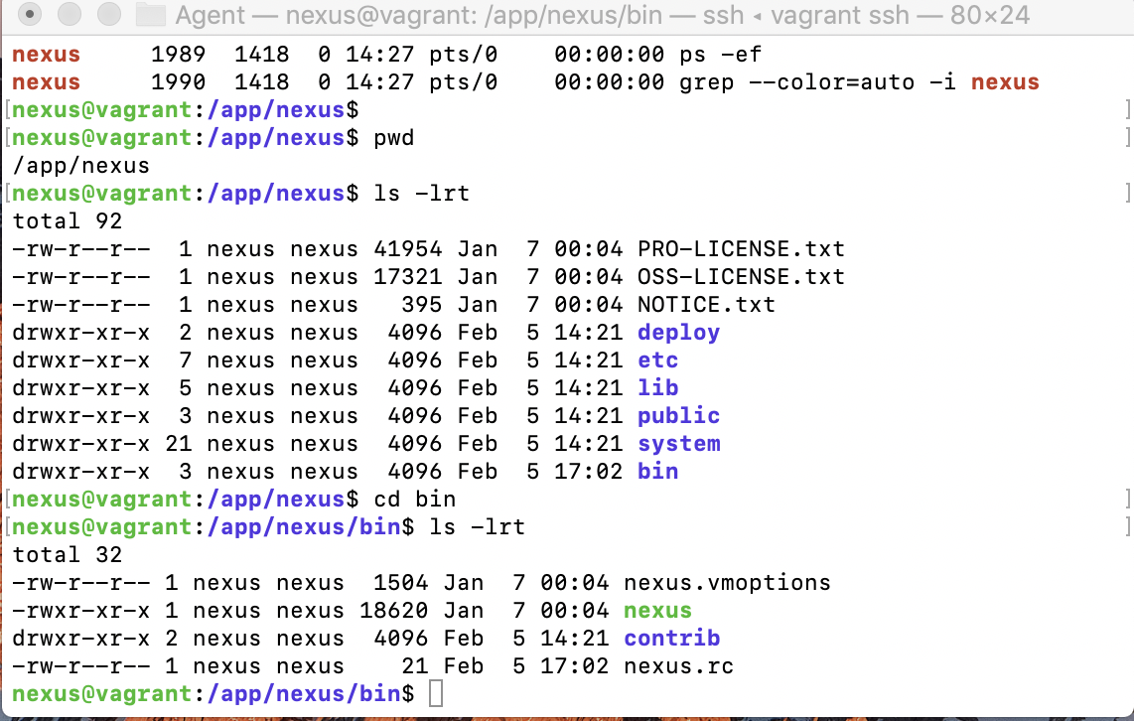

Execute the following command to add nexus service to boot.

sudo chkconfig nexus on

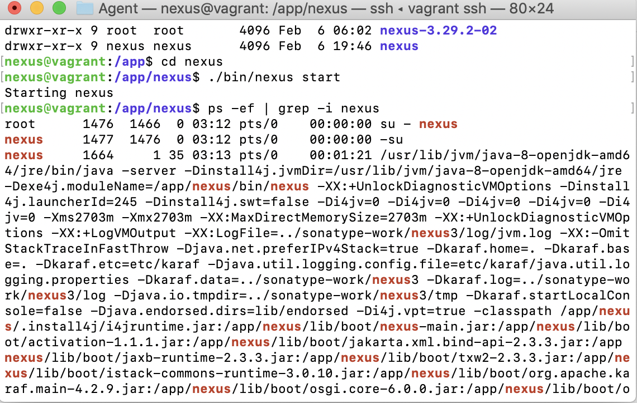

To start the Nexus service, use the following command.

Or use:

**nexus@vagrant**:**/app/nexus**$ ./bin/nexus start

./nexus start

sudo systemctl start nexus

The above command will start the nexus service on port 8081. To access the nexus dashboard, visit http://:8081. You will be able to see the nexus homepage as shown below.

[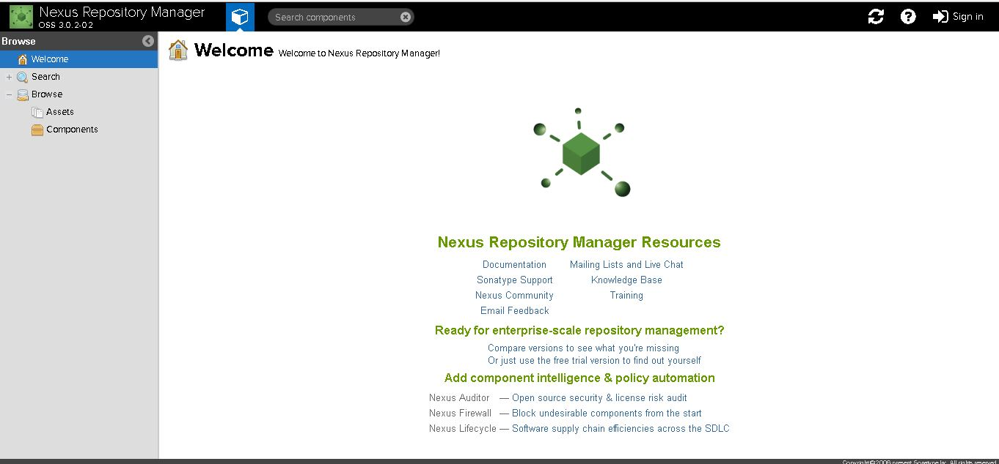](https://devopscube.com/wp-content/uploads/2016/09/nexus-setup.jpg)

To log in, use the default username and password.

Default username is admin

You can find the default admin password in /app/sonatype-work/nexus3/admin.password file.

cat /app/sonatype-work/nexus3/admin.password

password: 133c54d7-fe94-4536-a029-dba88ce249f5

For stopping,

sudo systemctl stop nexus

For restarting,

sudo systemctl restart nexus

Step: Once Nexus will install and running, we can check the status by:

Ps-ef | grep -I nexus

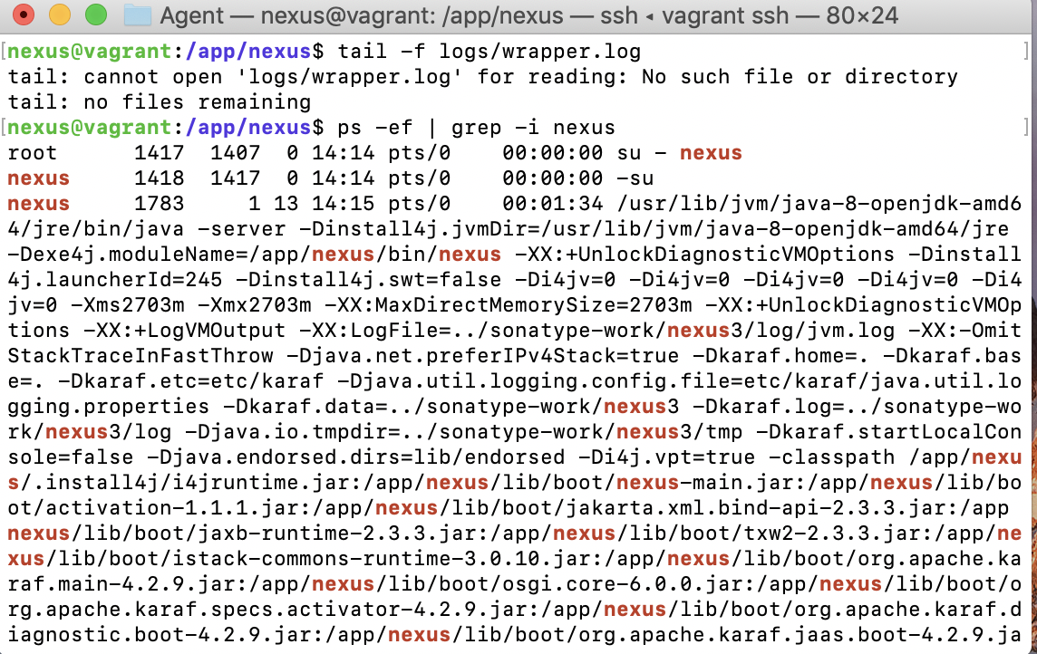

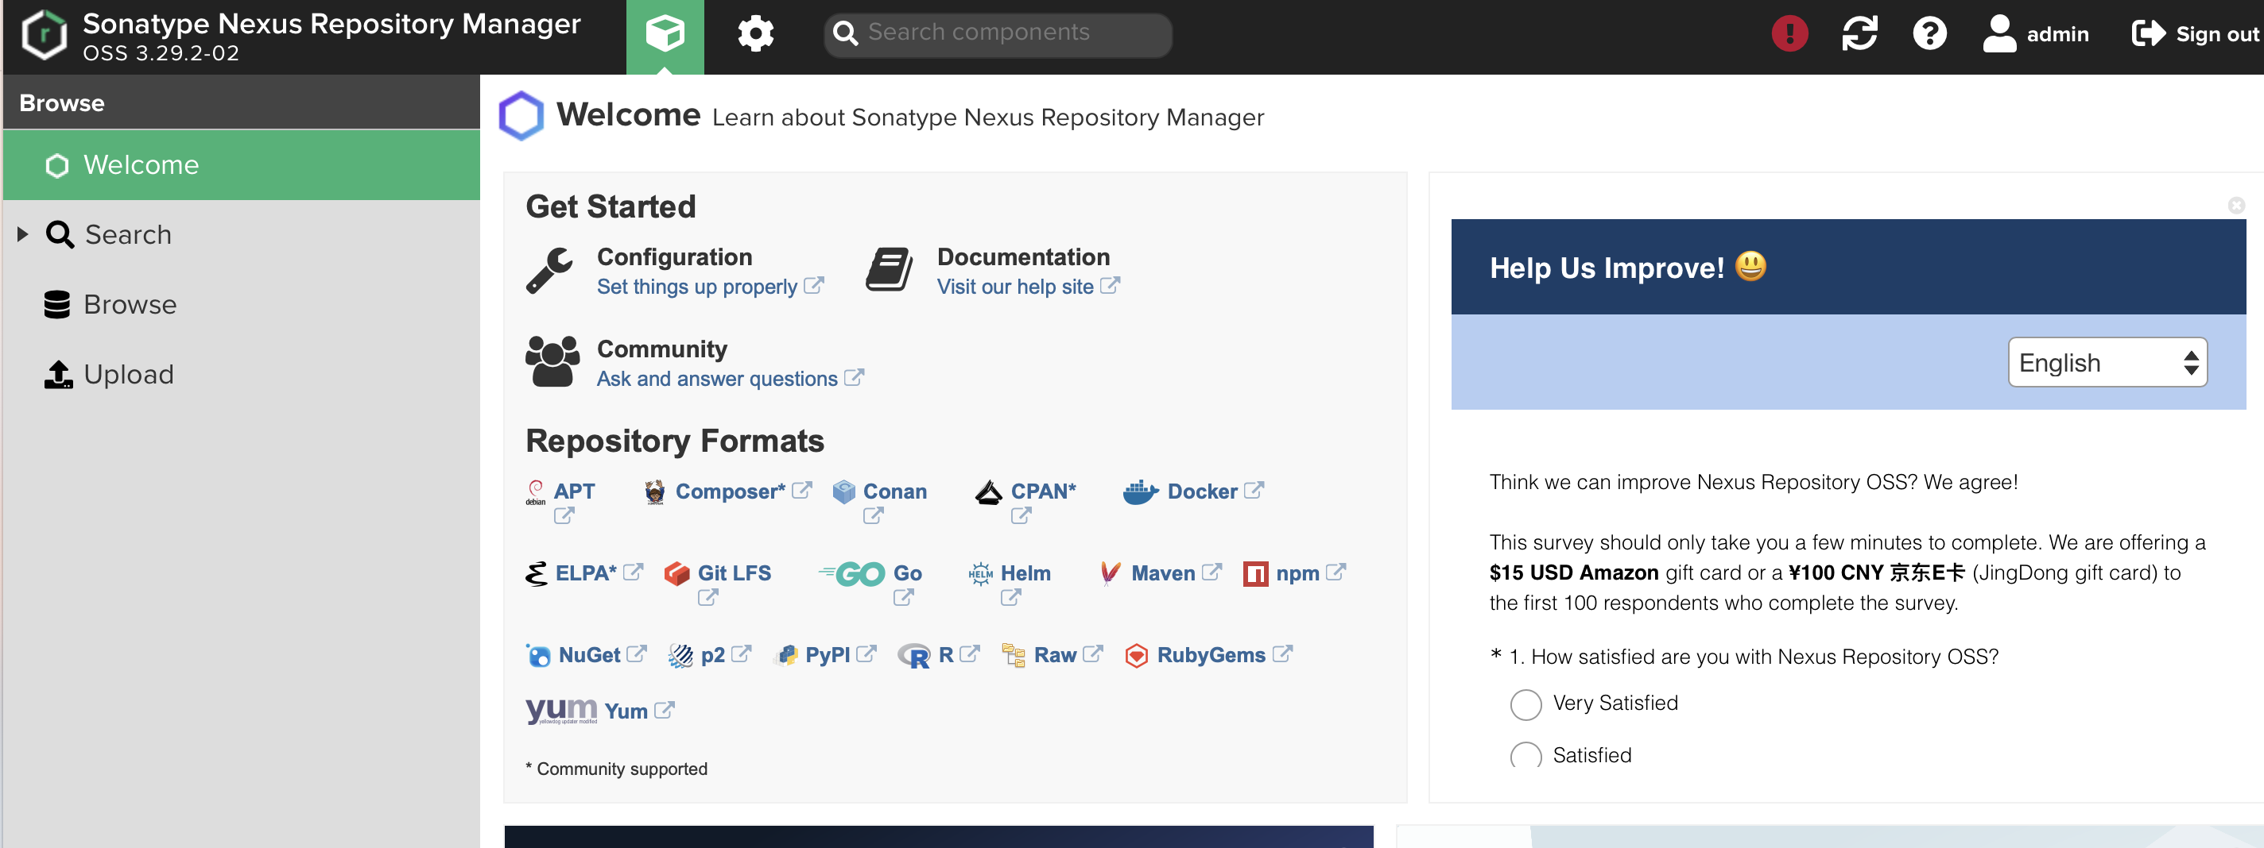

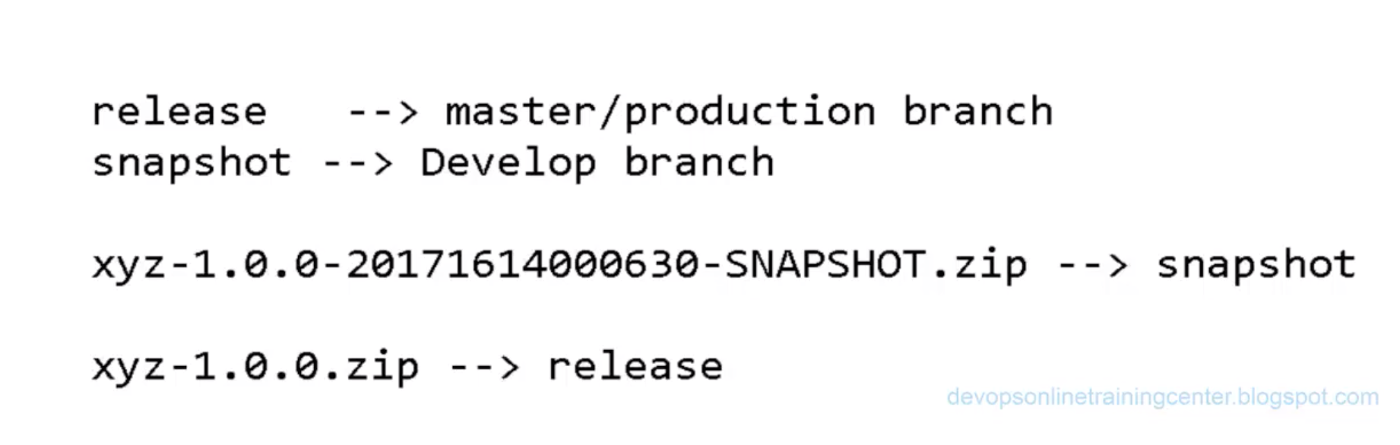

* + 1. Create Repositories

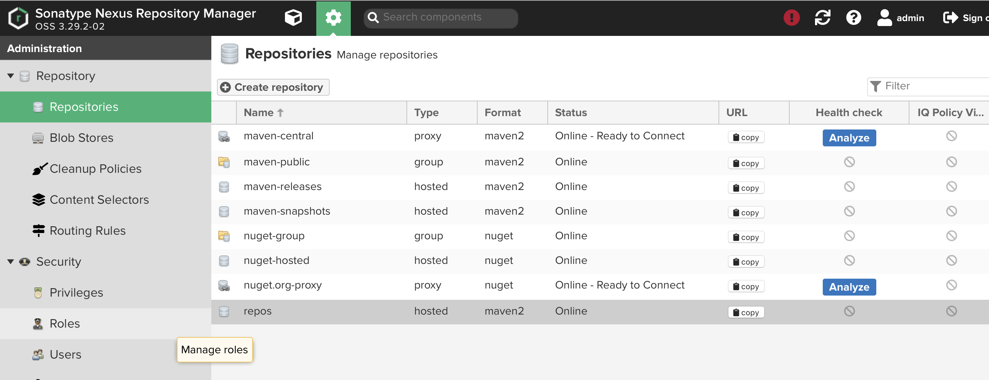

* + 1. Make value as mentioned below:

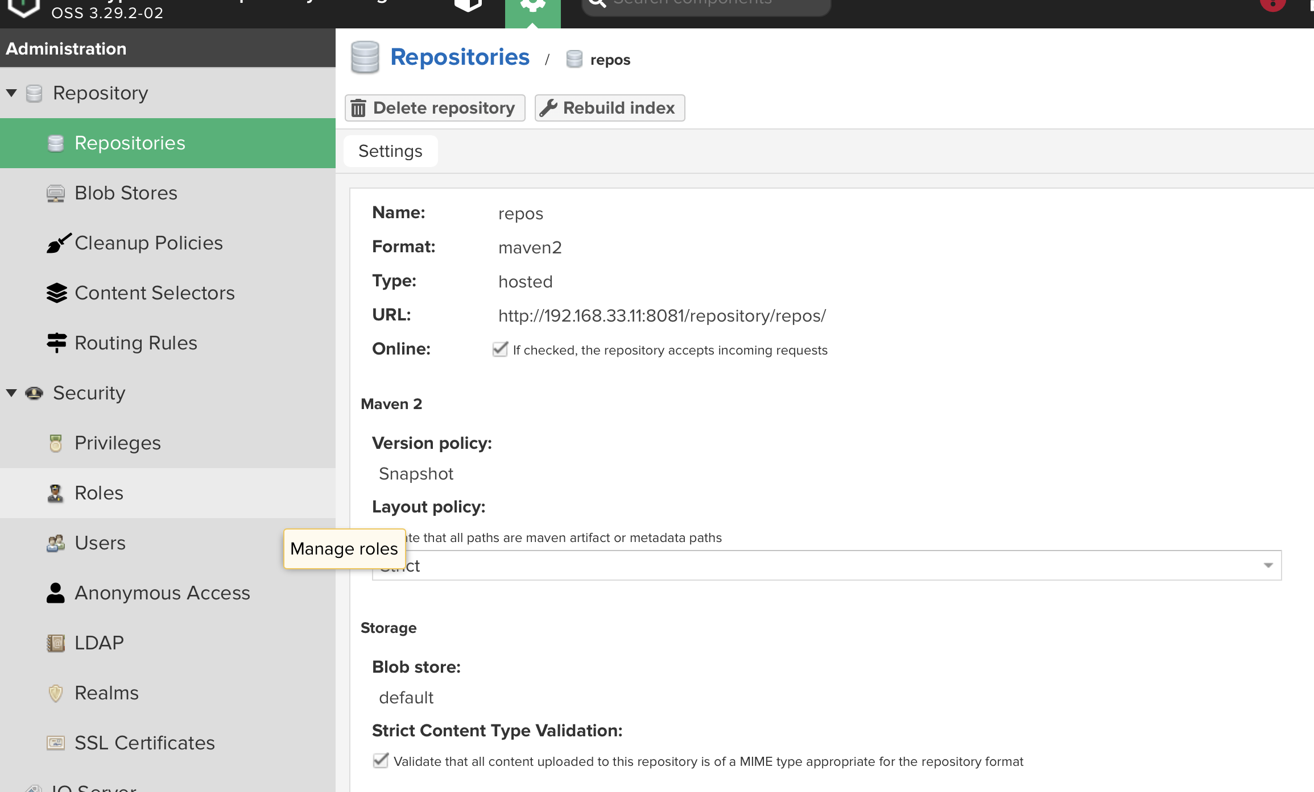

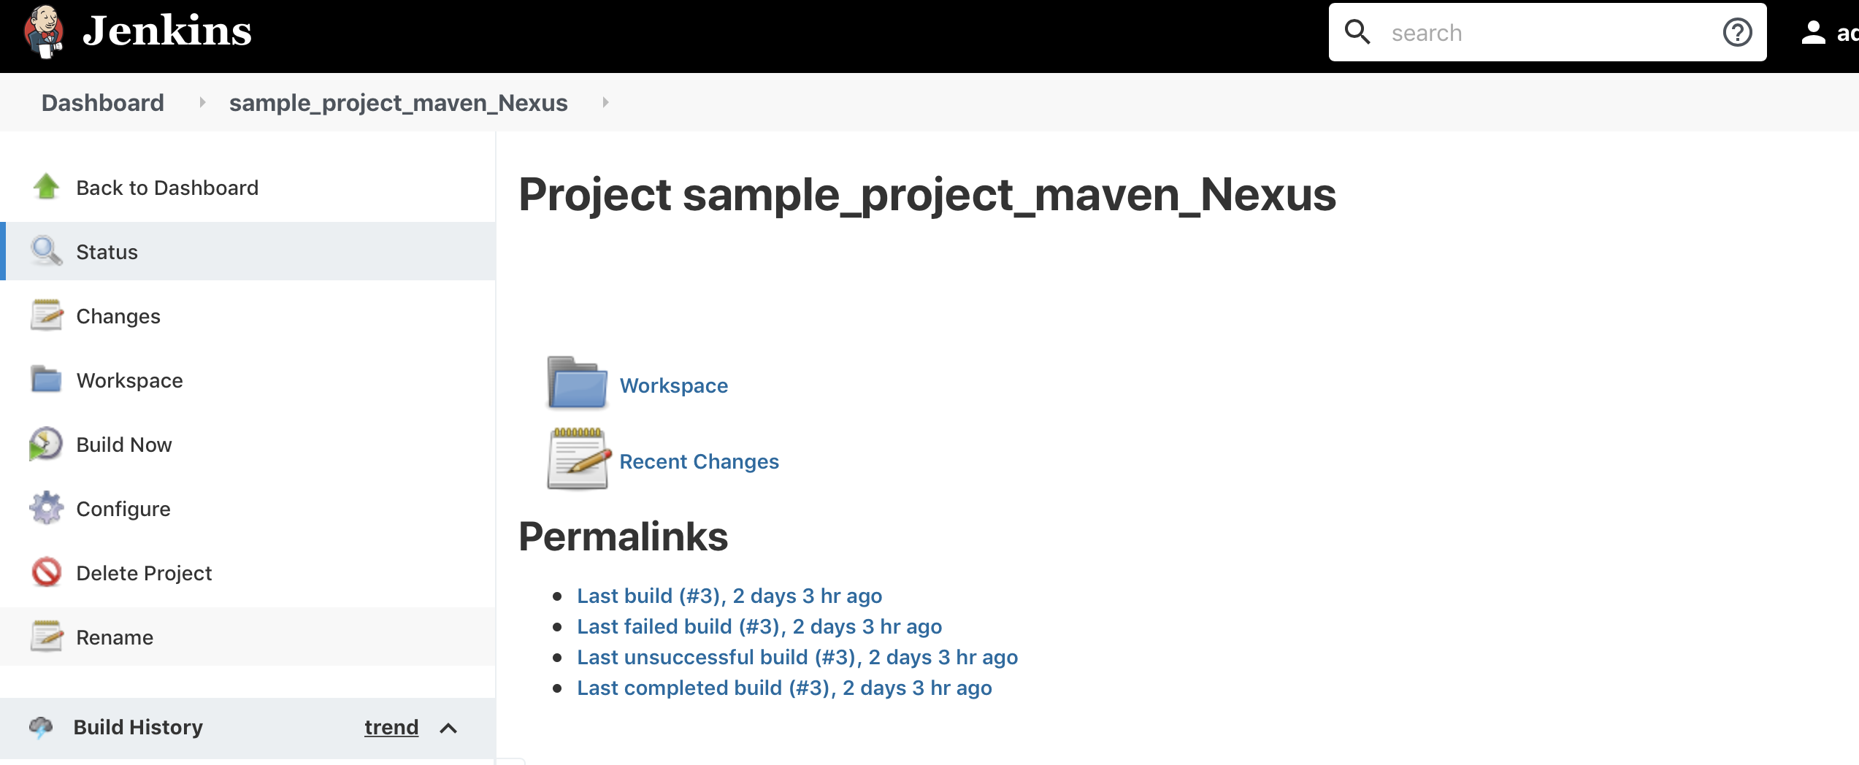

Install the plugin nexus artifact uploader:

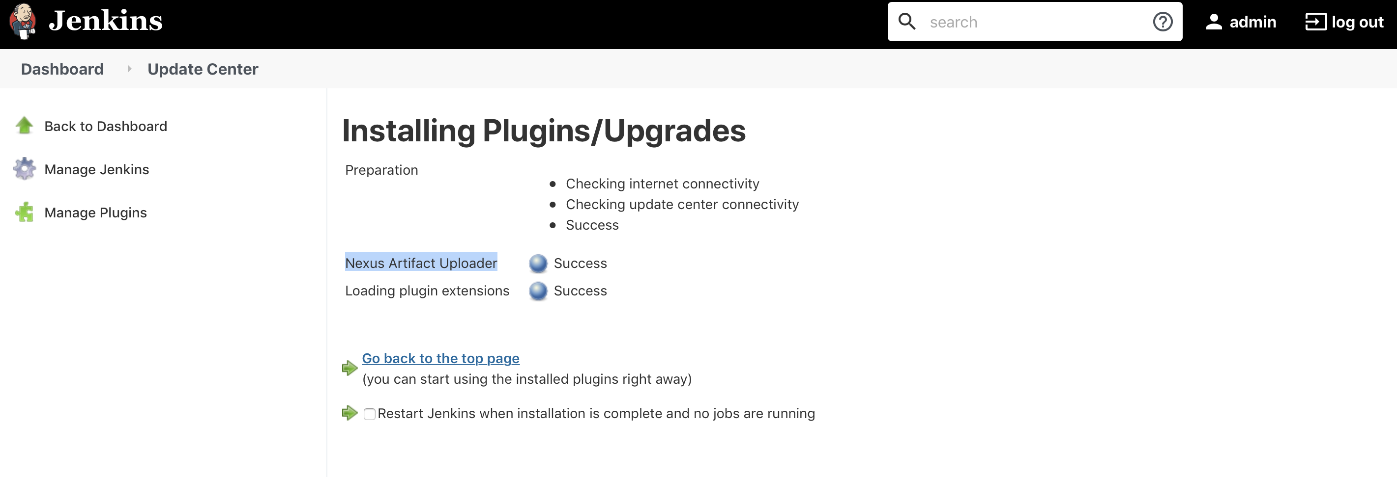

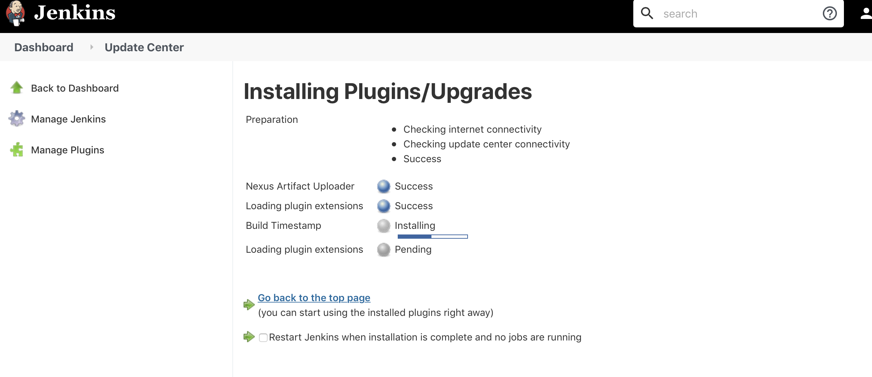

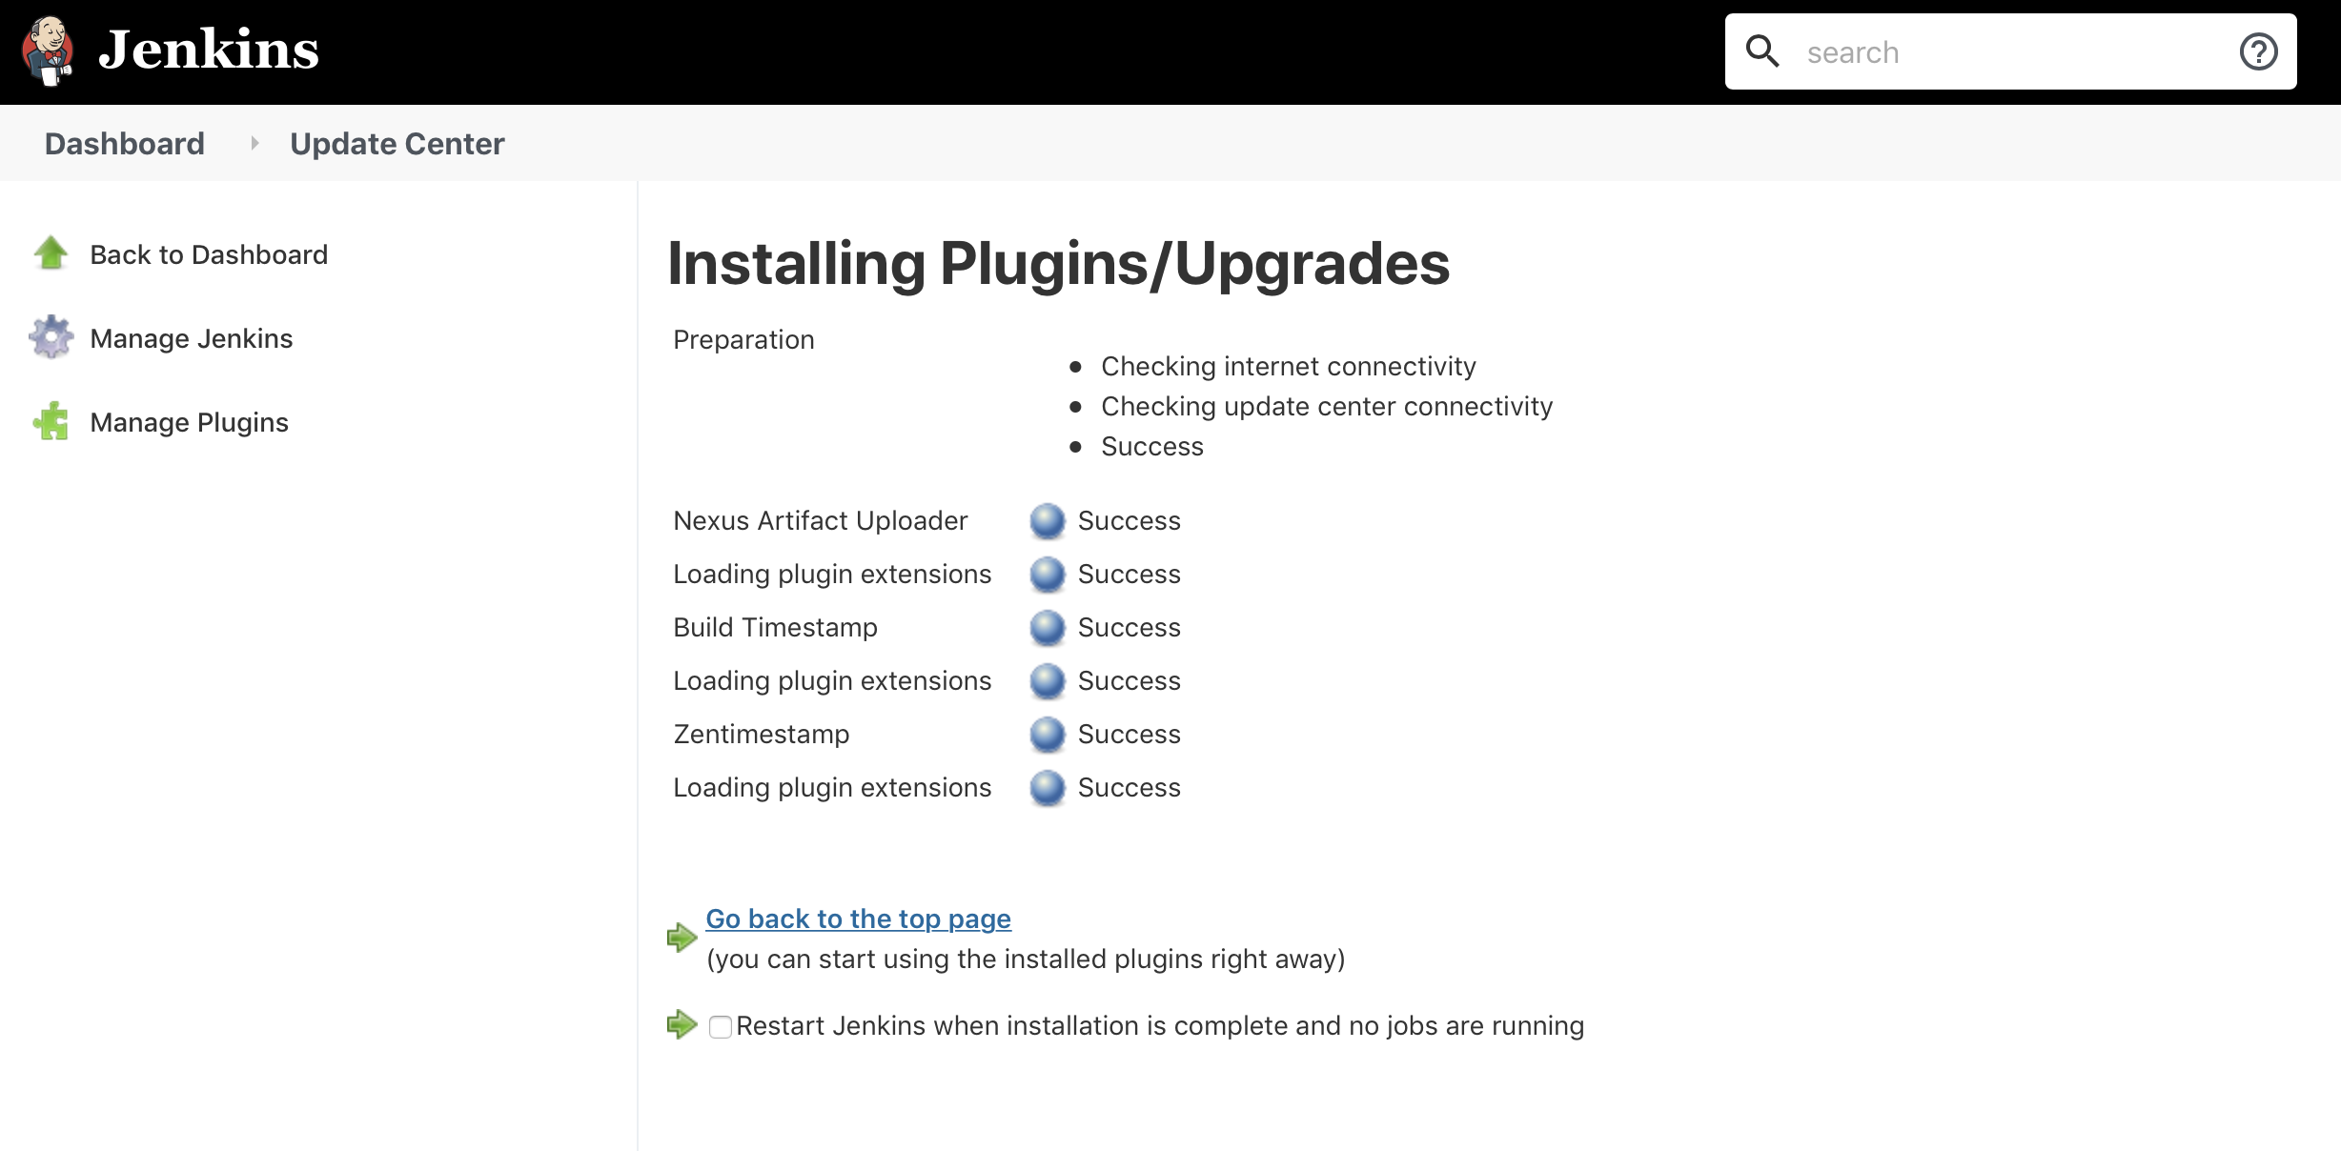

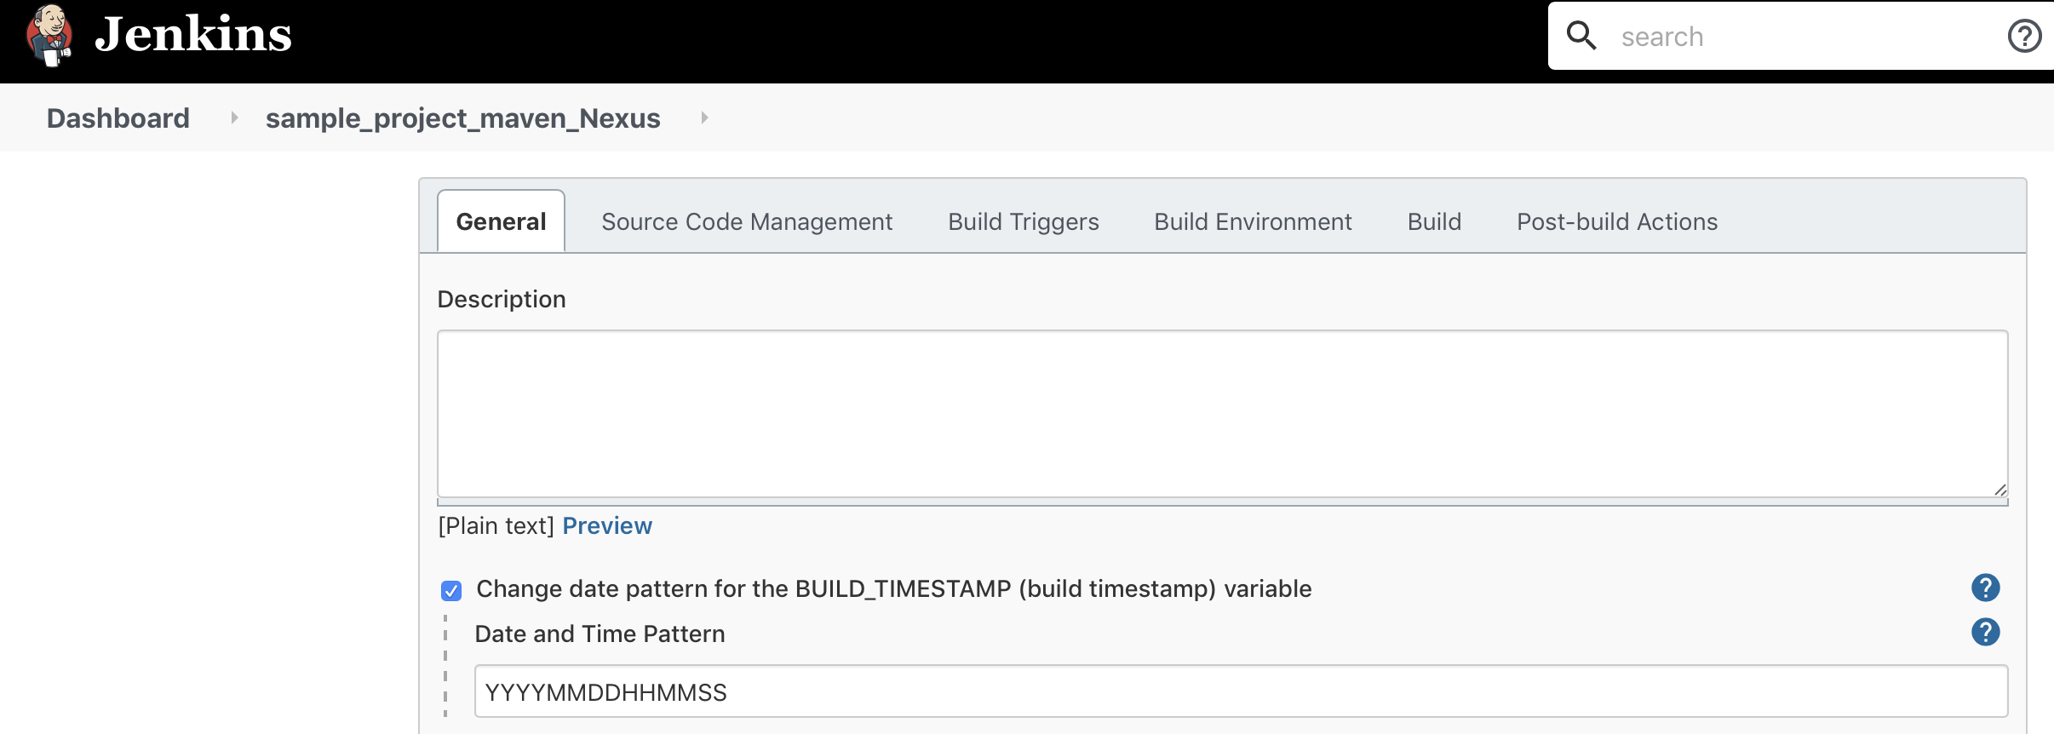

We can use the variable BUILD\_TIMESTAMP anywhere and that will replace with

Date.



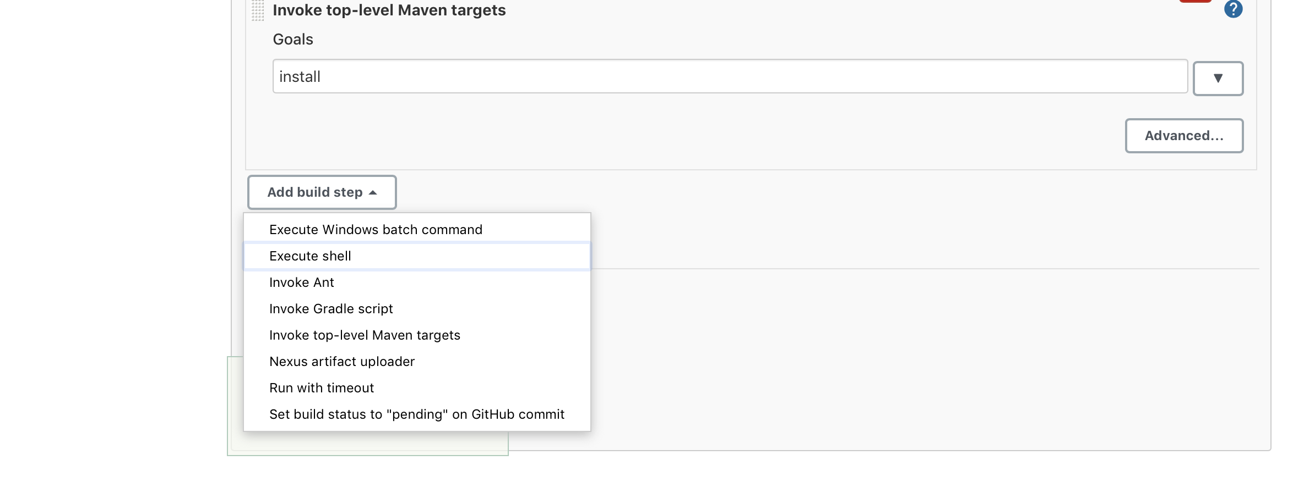

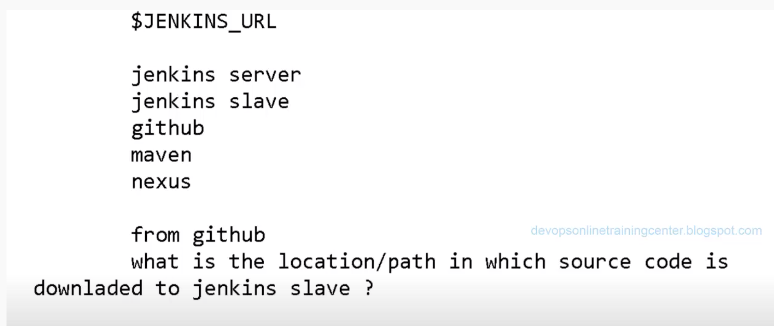

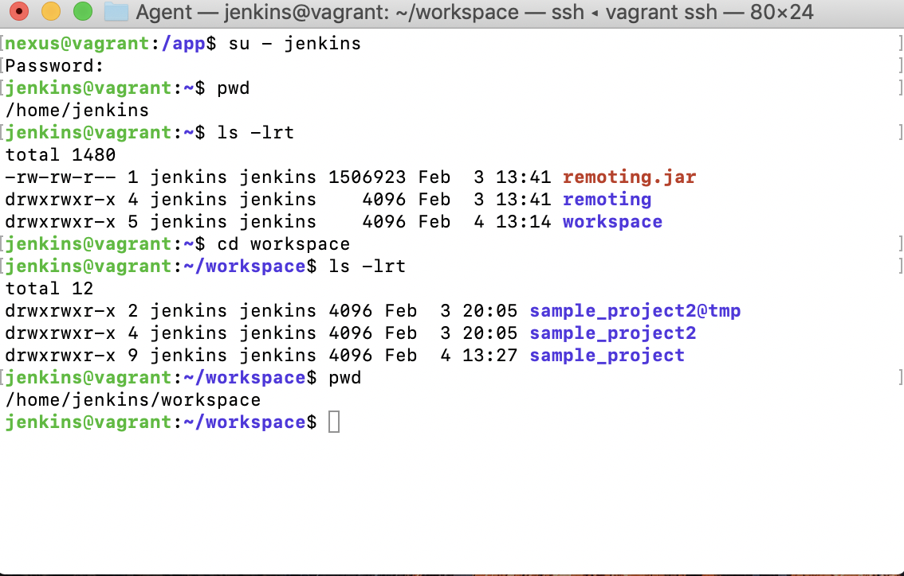

To find the war file

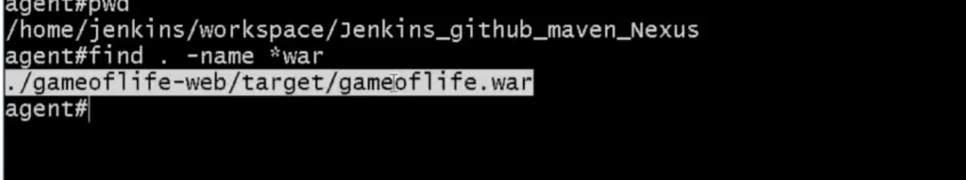

Memory Issue:

=================

<https://stackoverflow.com/questions/34748464/ubuntu-elasticsearch-error-cannot-allocate-memory>

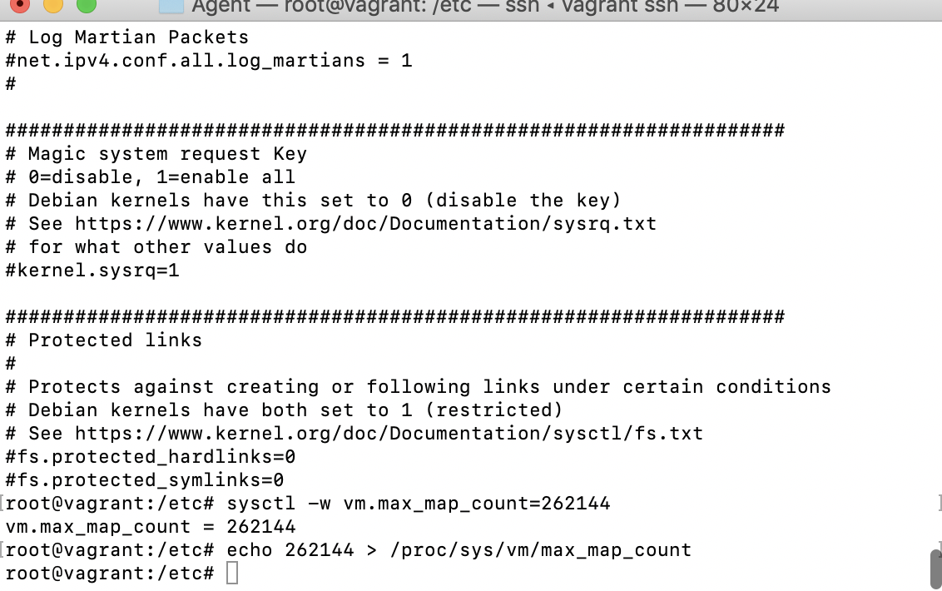

Login as the user you want .

type in the terminal as

ulimit -a

share the values if you can   
look for the core file

usually i will set it as unlimited to the core-files.

ulimit -c unlimited

**Understanding Nexus Repository Manager 3 Basic Directories**



**Peter Lynch**

Created: November 03, 2016 20:18 - Updated: April 14, 2017 18:50

[Follow](https://support.sonatype.com/hc/en-us/articles/231742807-Understanding-Nexus-Repository-Manager-3-Basic-Directories/subscription.html)

[Refer to the book](http://books.sonatype.com/nexus-book/reference3/install.html#directories) for detailed descriptions of the Nexus runtime directory and file structures.

There are important directories to be aware of when managing a Nexus Repository Manager installation.

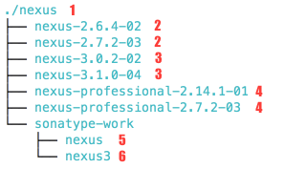

In the screenshot, we can see examples of how it might look when different versions of the repository manager are unpacked over time.

1 Installation Directory

This is the common parent directory in which all files related to the Sonatype Nexus Repository Manager will reside. This directory is created by you manually at a location of your choice. Its purpose is to eventually contain the **Application Directory** and **Data Directory** and be the common operating system location for all files related to Nexus Repository Manager.

2, 3, 4 Application Directory

A subdirectory of the **Installation Directory**, it contains the per version runtime application binary files used to launch and run Nexus. This includes Eclipse Jetty Server components, Nexus core libraries and control scripts. The name of this directory follows a pattern depending on the distribution used:  
  
**2 Nexus 2.x OSS Edition**: nexus-<version>  
**4 Nexus 2.x Professional Edition**: nexus-professional-<version>  
**3 Nexus 3.x OSS or Pro Edition:**nexus-<version>

The **Application Directory** is created [when a bundle distribution is extracted](https://support.sonatype.com/hc/en-us/articles/231740007).

5 Work Directory (Nexus 2) or 6 Data Directory (Nexus 3)

This is the main directory that stores your runtime specific Nexus configuration and component/artifact related files. The default location depends on what installer archive was extracted.  
  
**5 Nexus 2.x**: under the **Installation Directory** as sonatype-work/nexus  
**6 Nexus 3.x**: under the **Installation Directory** as sonatype-work/nexus3

If missing, the **Data Directory**or**Work Directory** are created [when a bundle distribution is extracted](https://support.sonatype.com/hc/en-us/articles/231740007). Any required runtime contents are *created automatically on first Nexus startup*.

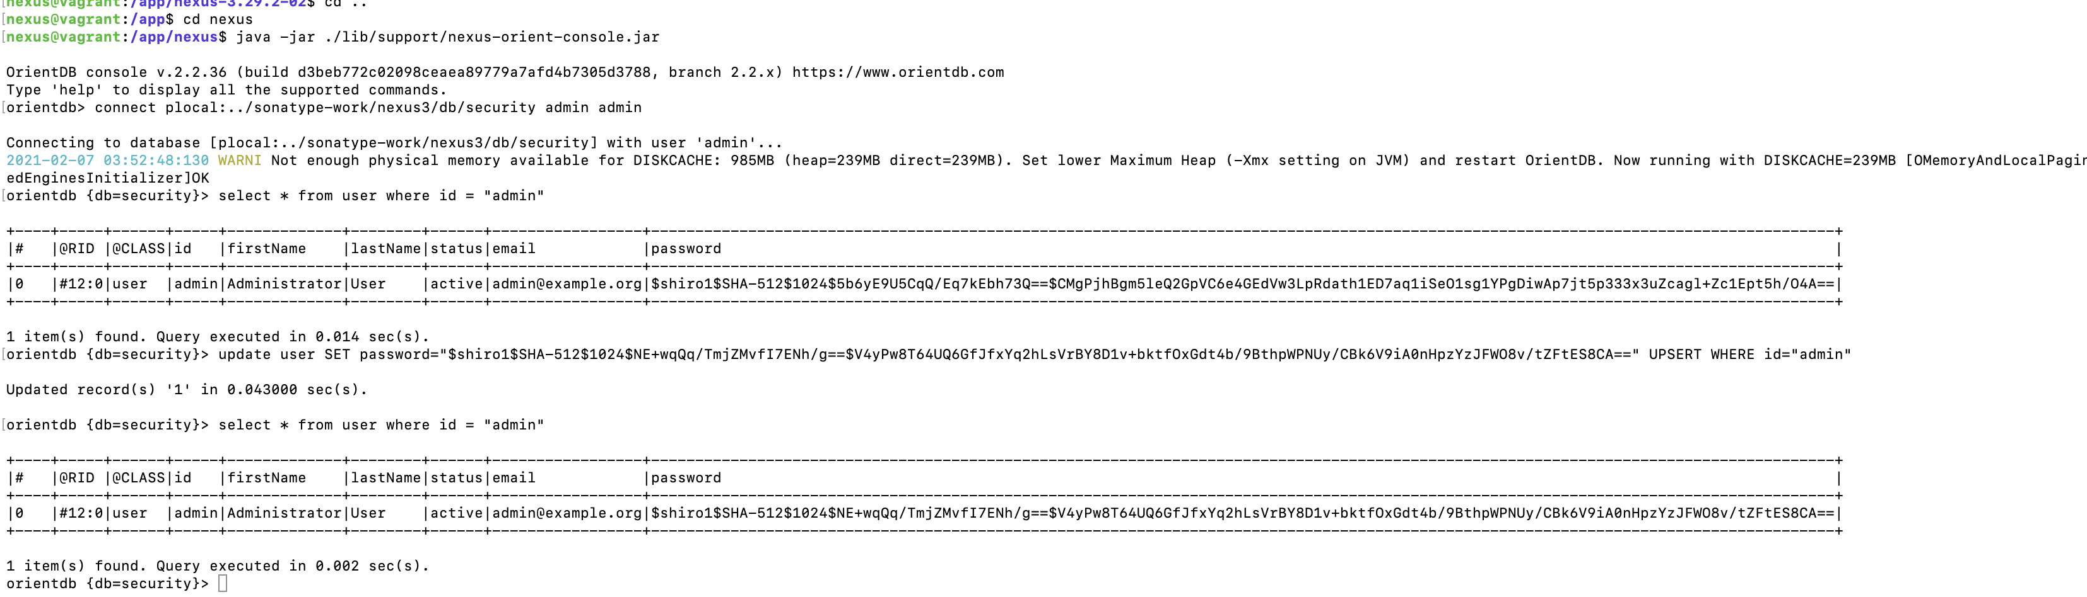

# How to reset a forgotten admin password in Nexus 3.x



**Peter Lynch**

Created: January 17, 2015 02:54 - Updated: January 25, 2021 21:40

[Follow](https://support.sonatype.com/hc/en-us/articles/213467158-How-to-reset-a-forgotten-admin-password-in-Nexus-3-x/subscription.html)

Nexus Repository Manager 3 includes a default 'admin' Administrator user account.

Versions before 3.17.0 had the default password of this account set to admin123 by default.

New installations of version 3.17.0 or newer do not have a set default password.

The following steps explain how to restore the default admin user account and set its password to admin123 :

1. Shut down nexus, and backup your <[Nexus Data Directory](https://support.sonatype.com/hc/articles/218707647)>/db
2. Access the OrientDB console using [these instructions](https://support.sonatype.com/hc/en-us/articles/115002930827-Accessing-the-OrientDB-Console).
3. Run the following command:

connect plocal:../sonatype-work/nexus3/db/security admin admin

You may need to adjust the path used in the connect statement depending on the location of your nexus data directory. It should be the path to the "db/security" directory in your data directory. An absolute path may be used.

1. After the connect command succeeds, check that the admin user exists:

select \* from user where id = "admin"

**If the admin user does exist**, issue this command in the console to update the admin user password to admin123 :

update user SET password="$shiro1$SHA-512$1024$NE+wqQq/TmjZMvfI7ENh/g==$V4yPw8T64UQ6GfJfxYq2hLsVrBY8D1v+bktfOxGdt4b/9BthpWPNUy/CBk6V9iA0nHpzYzJFWO8v/tZFtES8CA==" UPSERT WHERE id="admin"

**If the admin user does not exist**,  then issue the following two INSERT commands in the console to insert the admin user with password admin123and the default roll mapping:

INSERT INTO user (status, id, firstName, lastName, email, password) VALUES ('active', 'admin', 'admin', 'admin', 'changeme@yourcompany.com', '$shiro1$SHA-512$1024$NE+wqQq/TmjZMvfI7ENh/g==$V4yPw8T64UQ6GfJfxYq2hLsVrBY8D1v+bktfOxGdt4b/9BthpWPNUy/CBk6V9iA0nHpzYzJFWO8v/tZFtES8CA==')

INSERT INTO user\_role\_mapping (userId, source, roles) VALUES ('admin', 'default', 'nx-admin')

The query language is sql-like , but it is not SQL. See the [OrientDB Command Reference](https://orientdb.org/docs/2.2.x/Commands.html" \t "_self).

**At this point**, the admin user should be able to authenticate if the default security realms are in still in place. Verify you can login as the admin user using your web browser.

1. **Optional, if the admin user still fails to authenticate:** If the default security realms were removed from the active list, the default admin user will still not be able to authenticate, despite resetting the password.  
     
   **To reset the default security realms**, enter this command at the karaf prompt:

delete from realm

After this command succeeds and Nexus is restarted, the default security realms will be activated and any custom activated realms will have been removed.  
  
An admin user will then have to add back in any other security realms they had previously ( such as LDAP) using the Realms UI, to allow other users to authenticate.

1. **Optional, if the admin user is missing the "nx-admin" role:**

Check to see what roles the "admin" user has assigned to them:

select \* from user\_role\_mapping where userID = "admin"

If they are missing "nx-admin" use this command at the karaf prompt to fix:

update user\_role\_mapping set roles = ["nx-admin"] where userID = "admin"

1. **Optional, check to see if the admin user is active:**

Check to see if the "admin" user is active:

select status from user where id = "admin"

If they are not active, use this to make them active:

update user set status="active" upsert where id="admin"

1. To end the console session gracefully type "exit".
2. Start Nexus again using ./bin/nexus start or your regular service control command.

**nexus@vagrant**:**/etc/maven**$ vi settings.xml

<https://www.wikihow.com/Uninstall-Ubuntu-Software>

[**How to Uninstall Ubuntu Software**](https://www.wikihow.com/Uninstall-Ubuntu-Software)

**1.Open**

**[](https://www.wikihow.com/Image:Windowscmd1.png)**

**Terminal.** You should see the Terminal app icon on the left side of the screen; if not, click the Ubuntu icon in the top-left corner of the screen, type terminal into the search bar, and click **Terminal** when it appears.

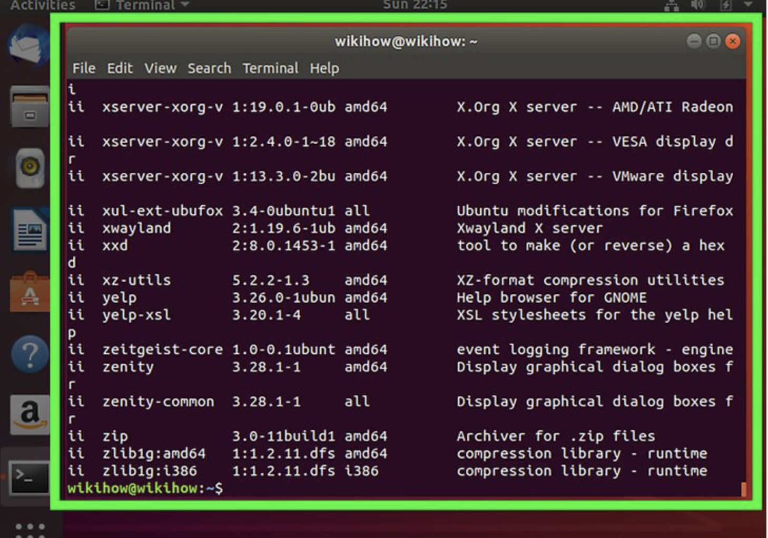

2. **Open a list of your currently installed programs.** Type dpkg --list into Terminal, then press ↵ Enter.

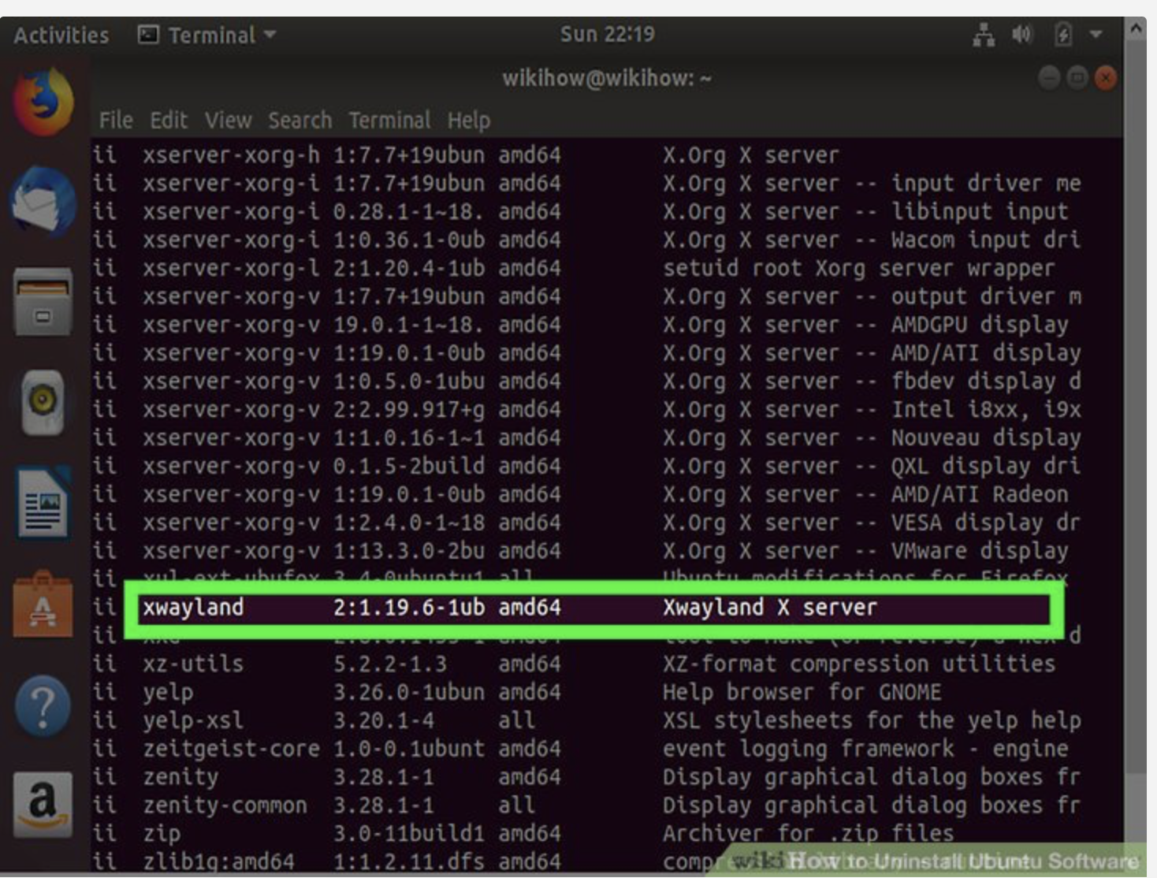

**3.Find the program that you want to uninstall.** You'll need to note the official name of the program file rather than the name of the program itself (e.g., "avg.exe" rather than AVG Antivirus).

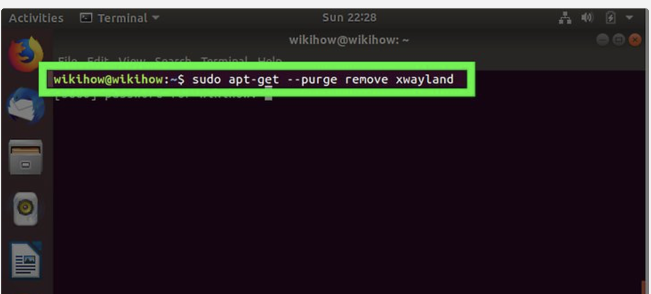

**4.Enter the "apt-get" command.** Type sudo apt-get --purge remove program into Terminal—making sure to use the program's actual name instead of "program"—and press ↵ Enter.

**5.Enter your root password.** Type in your superuser password, then press ↵ Enter.

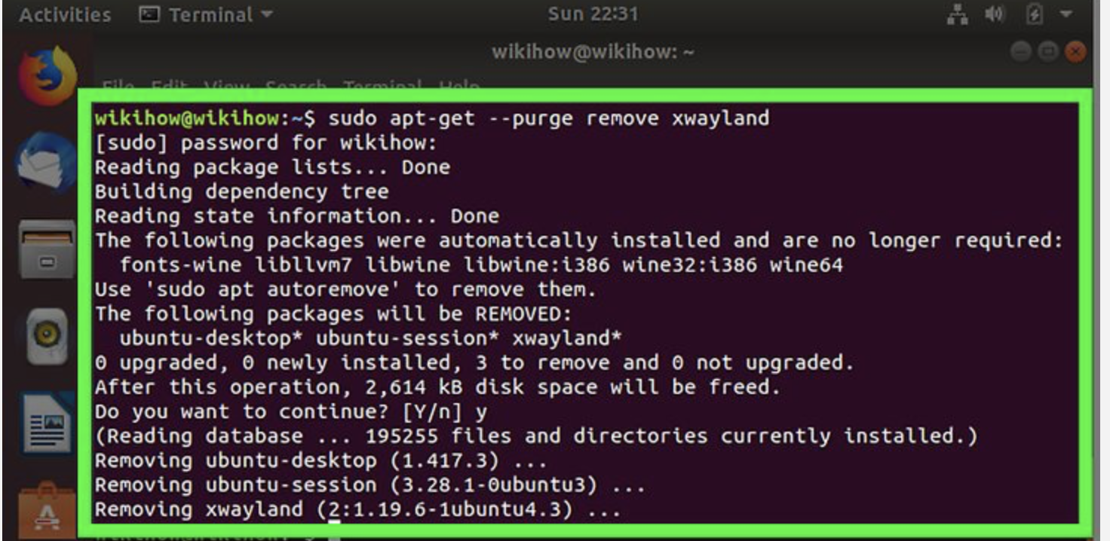

6. **Confirm the deletion.** Type in y and press ↵ Enter. Your program will begin to uninstall itself. Once it finishes, you can close Terminal.

* This process may take a while to complete depending on the size of the program.
* If your program isn't properly removed using the apt-get command, try using sudo aptitude remove program instead.

<https://support.sonatype.com/hc/en-us/articles/213465178-Adjusting-memory-allocated-to-Nexus>

https://support.sonatype.com/hc/en-us/articles/213464258-Sonatype-Nexus-Java-Service-Wrapper-3-2-3-Binaries-Solaris-x86-64

https://medium.com/@charinin/setting-java-home-environment-variable-in-ubuntu-e355c80e5b6c

**java-1.8.0-openjdk-amd64**

/usr/lib/jvm/java-1.8.0-openjdk-amd64

https://help.sonatype.com/repomanager3/installation/run-as-a-service

<https://www.youtube.com/watch?v=lABV64w560c>

Video to make setup of nexus on Ubuntu

<https://www.youtube.com/watch?v=LB1Zv8JgT6o>

We need to install maven also, if prompts error for maven software missing.

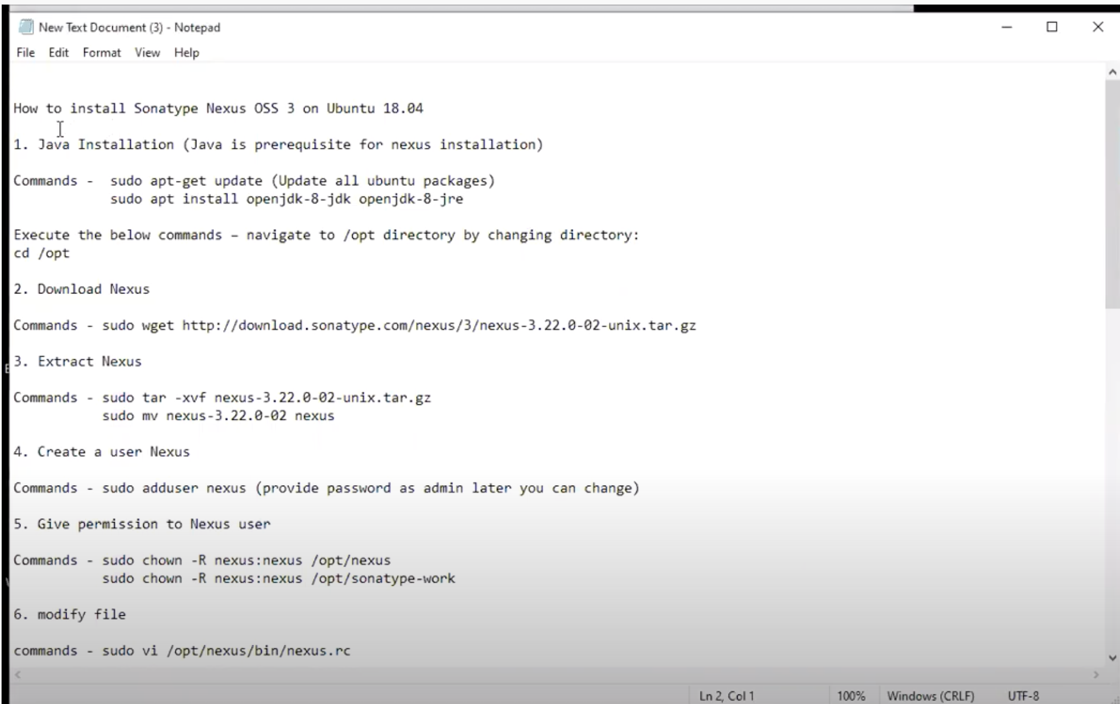

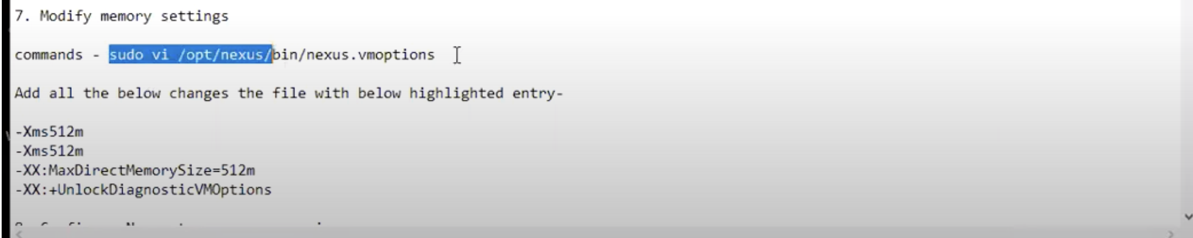

Modify the below value 2703m to 512m

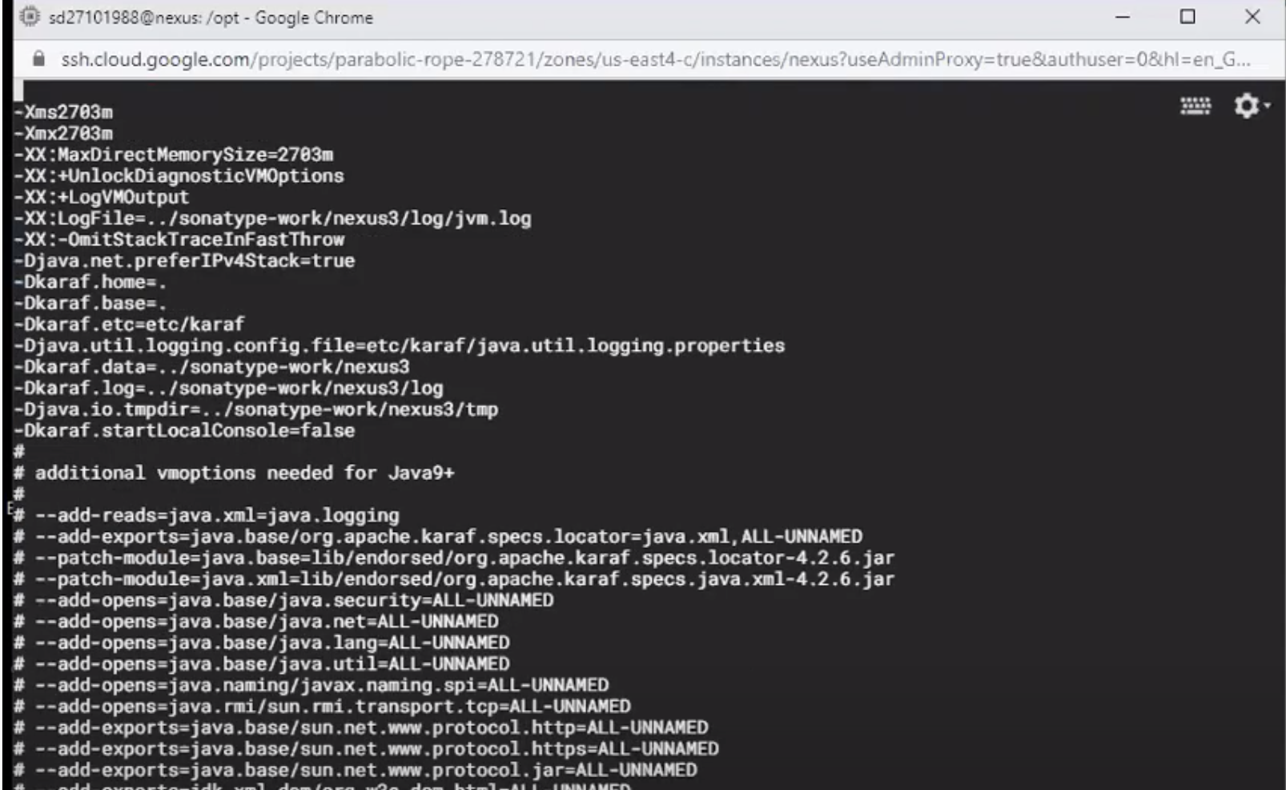

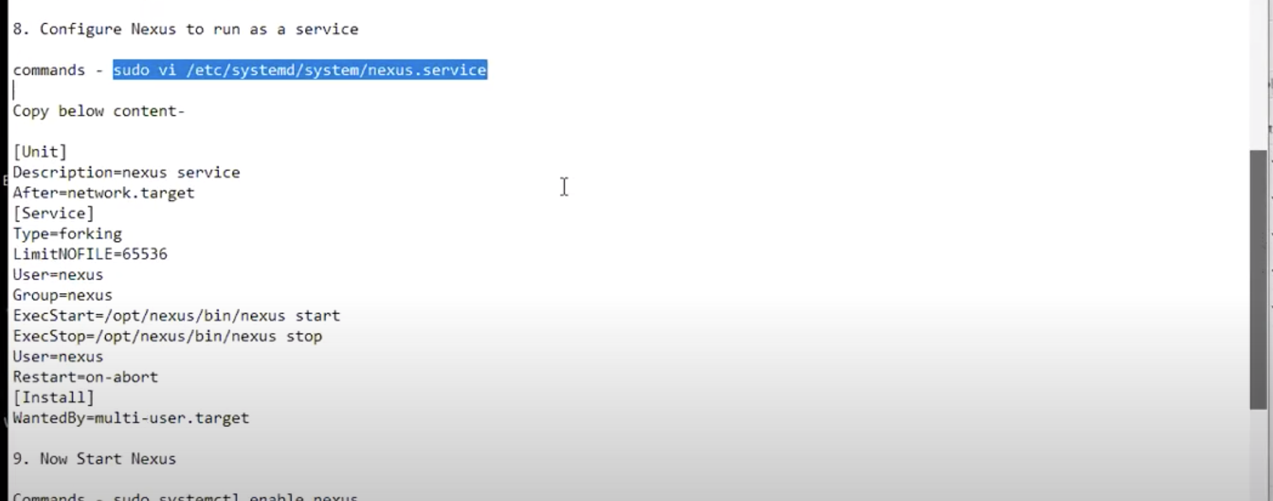

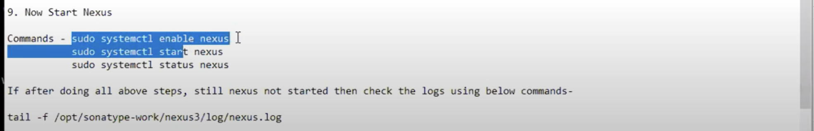

# Install Nexus 3 on Ubuntu 18.04 LTS – How to configure SonaType Nexus 3 on Ubuntu

[July 11, 2020](https://www.indiadailyfeeds.net/install-nexus-3-on-ubuntu-18-04-lts/) by [Sachin Deshmukh](https://www.indiadailyfeeds.net/author/user/)



### Install Nexus 3 on Ubuntu–

SonaType Nexus3 is java based application. Nexus3 is one of the popular binary repository managers, used for storing build artifacts such as Jars,WARs, EARs.

Step by step Installation guide to install Nexus on Ubuntu –

**Java** Installation (Java is prerequisite for nexus installation)

Java  
sudo apt-get update  
sudo apt install openjdk-8-jdk openjdk-8-jre

Execute the below commands – navigate to /opt directory by changing directory:  
cd /opt

Download Nexus  
sudo wget http://download.sonatype.com/nexus/3/nexus-3.22.0-02-unix.tar.gz

Extract Nexus  
sudo tar -xvf nexus-3.22.0-02-unix.tar.gz  
sudo mv nexus-3.22.0-02 nexus

Create a user called Nexus  
sudo adduser nexus

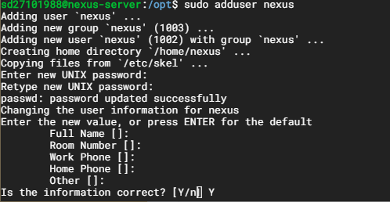

provide a password which you can remember at later stage.

Give permission to Nexus user  
sudo chown -R nexus:nexus /opt/nexus  
sudo chown -R nexus:nexus /opt/sonatype-work

sudo vi /opt/nexus/bin/nexus.rc

Do some modification such as –

run\_as\_user=”nexus”

Modify memory settings  
sudo vi /opt/nexus/bin/nexus.vmoptions:  
Add all the below changes the file with below highlighted entry-

-Xms512m  
-Xms512m  
-XX:MaxDirectMemorySize=512m  
-XX:+UnlockDiagnosticVMOptions

Configure Nexus to run as a service  
sudo vi /etc/systemd/system/nexus.service

Copy below content-

[Unit]  
Description=nexus service  
After=network.target

[Service]  
Type=forking  
LimitNOFILE=65536  
User=nexus  
Group=nexus  
ExecStart=/opt/nexus/bin/nexus start  
ExecStop=/opt/nexus/bin/nexus stop  
User=nexus  
Restart=on-abort  
[Install]  
WantedBy=multi-user.target

Now Start Nexus  
sudo systemctl enable nexus  
sudo systemctl start nexus  
sudo systemctl status nexus

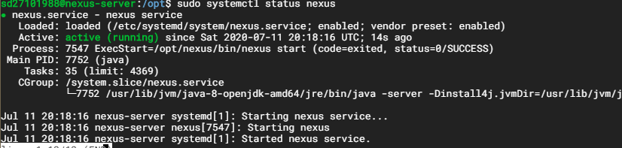

If after doing all above steps, still nexus not started then check the logs using below commands-

tail -f /opt/sonatype-work/nexus3/log/nexus.log

Once Nexus is successfully installed, you can access it in the browser by  
URL – http://ip-address:8081

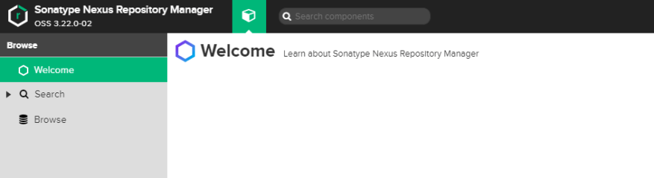

Now click on Sign in, enter admin as user name and password by executing below cat command.

cat/opt/sonatype-work/nexus3/admin.password  
Now change admin password as admin1234

Now click next, do not check Enable anonymous access.

Click on Finish button.

Now login with user name/password is admin/admin1234.

ERROR: If version policy:snapshot gives us error , then replace it with “Release”

Version policy.

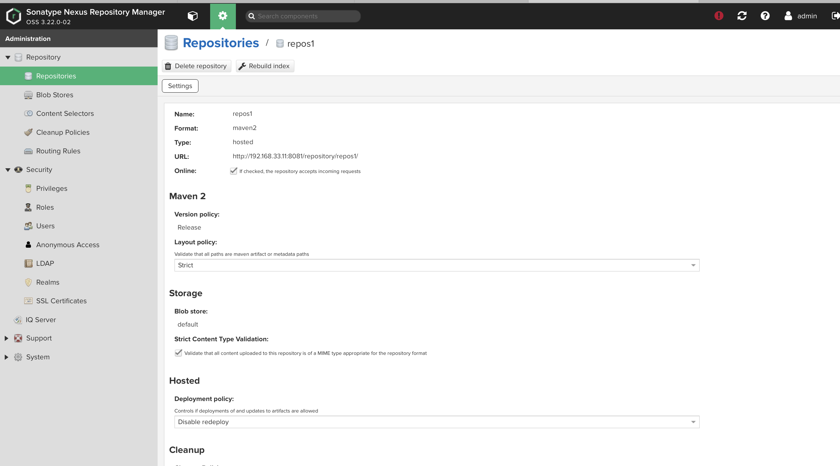

<URL:http://192.168.33.11:8081/repository/repos1/>

It should be same entered in Jenkins dashboard.

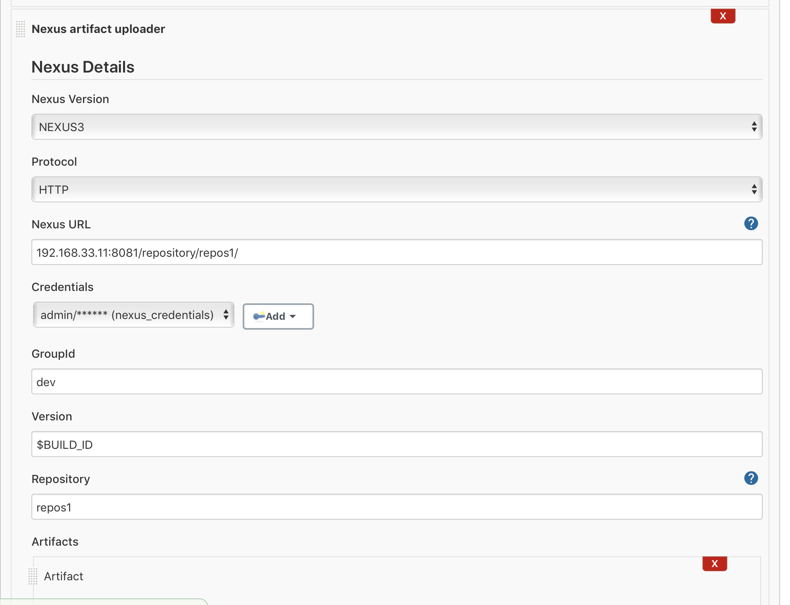

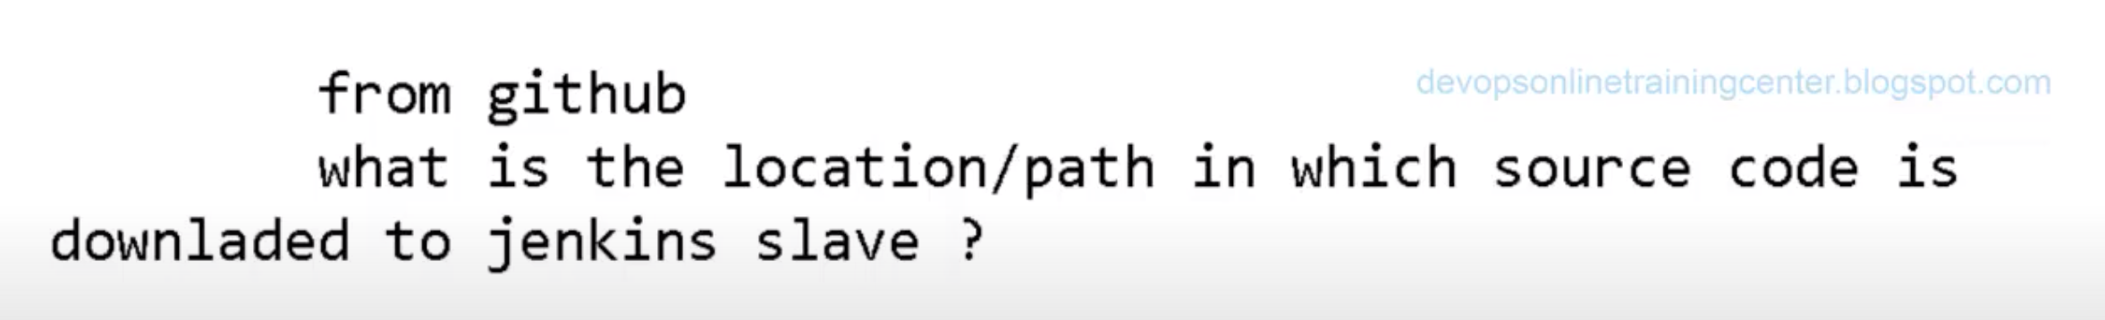

Workspace of home directory of Jenkins slave where we can store source code.

First it create job with jobName in workspace,

To find the war file which created from GitHub :

**jenkins@vagrant**:**~/workspace/sample\_project\_maven\_Nexus**$ find . -name \*war

./gameoflife-web/target/gameoflife.war

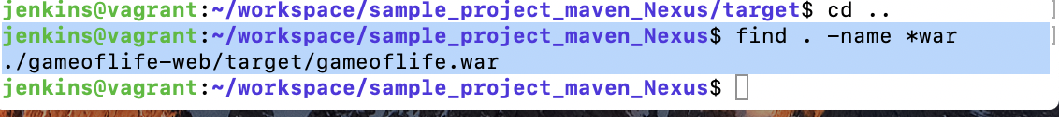

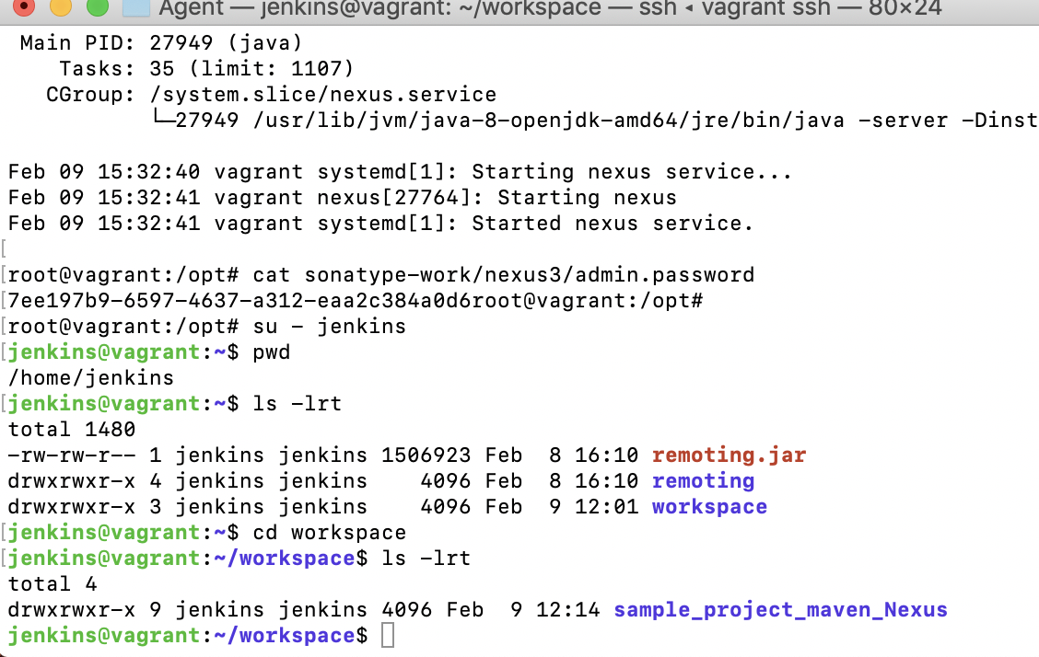

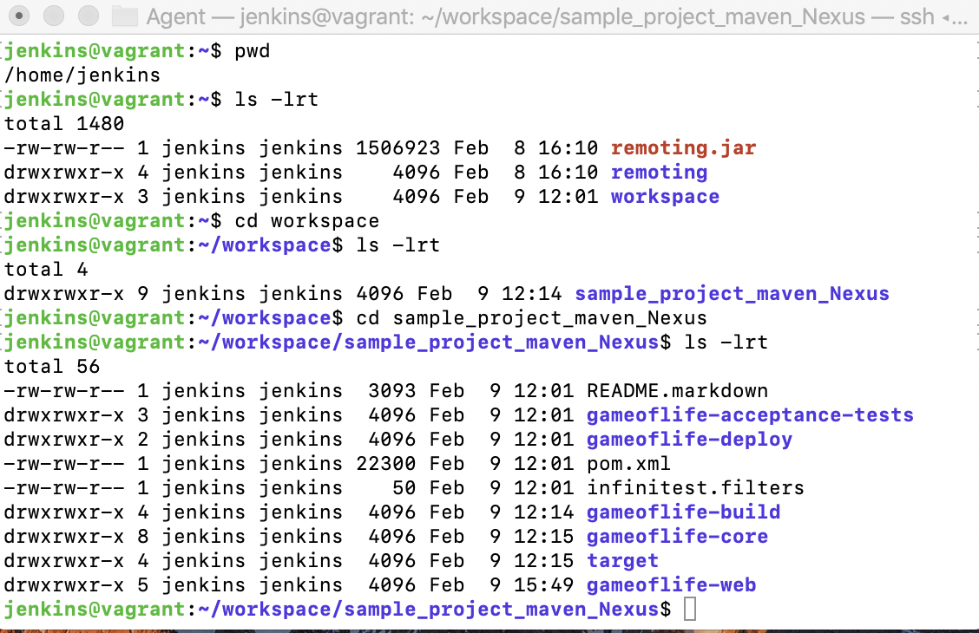

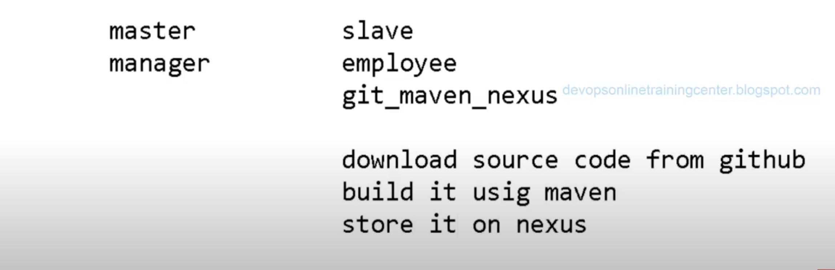

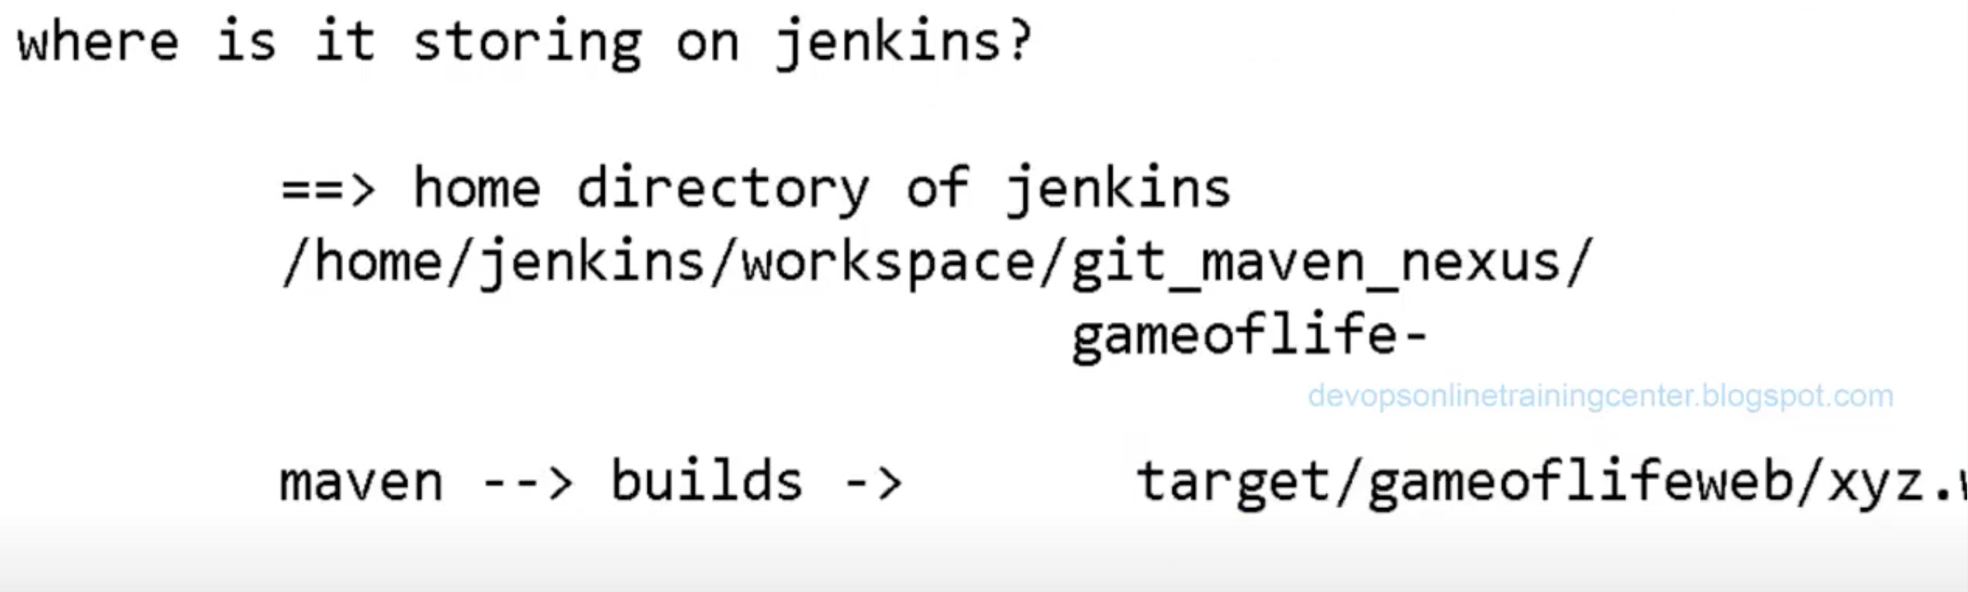

1. Source code is stored in home directory of Jenkins.

/home/Jenkins/workspace/git\_maven\_nexus

1. Maven builds the source code and store it in target/gameoflifeweb/gameoflife.war
2. That location should be entered in Jenkins under Artifacts section.
3. It is found in slave machine. All maven,git & Jenkins should be install in slave machine.

